X`

**COMP1640**

**Enterprise Web Software Development**

**Class: TCS2010**

**Name: Ho Anh Dung GCS18594**

**Le Hai Linh GCS18271**

**Nguyen Van Tin TCS19**

**Ngo Anh Tu GCS18**

# I. Table of Contents:

**I. Table of Contents: 2**

**II. Project Introduce: 3**

**III. Database: 5**

ERD Diagram: 5

**VI. Requirement: 5**

Functions 6

Use case: 7

Activity Diagram: 9

Sequence Diagram: 14

**V. Design 33**

**VI. Testing 48**

Test Plan: 48

Test Log: 51

**VII. Agile Method: 54**

Produce Backlogs: 54

In Progress: 56

Daily Meeting: 57

Burndown Charts 57

**VIII. Product: 58**

**VIX. Links: 68**

**X. References: 69**

# II. Project Introduce:

The project we received this time, brought down by the school board for teamwork is to build a website-based system that can collect submission data from students, manager students' courses, teacher coordination and class division for teachers and students. Website is based on similar CMS of Greenwich to develop, have more functions and uses.

As required, this is a group subject and is divided into groups for each class member to do this project. The team should rely on members who have the most professional and ideal working methods. Our team consists of the following people: database designers, programmers, web designers, testers, and Scrum docs, experts who can assist with full web access. Better with this team, no one has to take on the project manager in our team, so this will elect one person to be the team leader to divide the work among each team member so that they can do better on the project.

The obvious requirement is that we need to build a secure web-based role-based system to collect student contributions to the annual college journal within a major university. The system should meet the following criteria:

* The school needs a marketing manager to oversee the processes of each department.
* All departments must have a marketing coordinator responsible for managing each process for their Faculties.
* All students have the opportunity to submit one or more articles as Word documents to the journal on time. Students can upload high-quality images to replace the text.
* All submitted submissions can be edited by the deadline date, deleted and re-loaded before the deadline. After the deadline, the Student cannot delete, edit, or submit any new posts.
* Students must comply with the terms and conditions before they can apply.
* Once the donation is submitted, the system will send an email notification to the Faculty's marketing coordinator, who must give a comment within 14 days so that if there is a mistake, students can correct and submit if you are still in the submission period. A marketing coordinator may only access student contributions in their Faculty.
* Each marketing coordinator has the ability to interact with students in their faculty to edit contributions and select those contributions for publication.
* The university's marketing manager can view all selected contributions but cannot edit any. They can download all selected contributions after the last close date as a ZIP file for out of the system.
* Admin can close for each subject when the closing date has ended. Admin can create accounts, decentralization, topic, Department, so that Coordinator, Student, Marketing Manager, Guest can easily log in and choose their correct rights to access the system, in addition to external users can’t access. School system without admin consent. Admin, in addition to creating, they can delete and correct information when there is something wrong or missing.
* One guest account per Faculty can be used to view selected reports.
* Statistical analysis is required (e.g. number of contributions per Faculty).
* Interface must be suitable for all devices (e.g. mobile phone, tablet, desktop).

# III. Database:

## **ERD Diagram:**

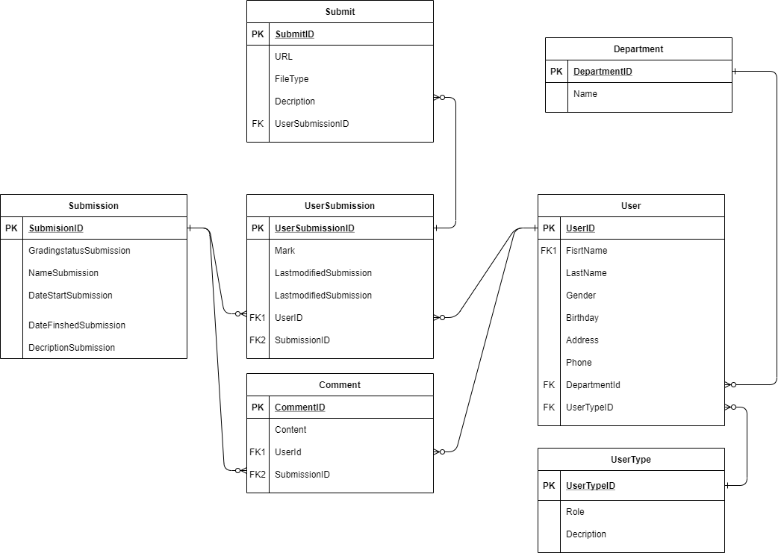

**Figure 1: ERD Diagram**

# VI. Requirement:

- In this scenario there is a need to build a secure web-based role-based system for collecting student contributions to the annual college journal in a large university. The generated system should meet the following:

- In a school there must be a Marketing (Marketing Manager). The Marketing Manager will create and oversee the process of the Marketing Coordinator to support and be responsible for the Faculty's process.

- For all students it is possible to view Faculty information students take and only students to view that Faculty information.

- For Administrators, it is responsible for opening the submission portal of the Faculties for students to submit papers and each article will have 2 deadlines (so that students can edit their article or submit them late in the first deadline). And all students can submit multiple papers in Doc, PDF, IMG, ... and students must submit them before the deadline, after the deadline will be locked. Before submitting a submission all students must agree to the Terms and Conditions before they can submit.

- Instructors can only see the submission of that Faculty, then choose the best work of that Faculty and send it to the Marketing Manager who has the right to download the work as a Zip file. And the Moderators have the right to comment on students' work via chat, video call, feedback, ...

- After that, the school system will create reports for students on their article by mail. In the papers, students also have the right to comment and vote for the best work of the Faculty until the deadline, but not to see other people. In each Faculty, the school system will create a Guest account to be able to view the article report.

## **Functions**

**Admin :** In the system, Admin has an important role in the system, the function of Create / Edit / Delete of Topic, Department and Roles. Admin can Create / Edit / Delete User, can Detail User and Assign User function and role in system.

**Coordinator** : In the Coordinate system can View and Detail Topic they manage. And Coordinator has the function to Mark, Comment and Chat with Student article in Chat page.

**Student** : In the student system, there is a function to submit papers to the system, comment and chat with student in Chat page and View topics that students are studying.

**Manager** **Marketing** : In the system, Manager Marketing has a View Topic function and can view the coordinator articles. Then Marketing has the function Choose Submit and Download all the articles in the topic as a Zip file. Manager Marketing can to join Chat room to chat with Coordinator and Student in Chat page.

**Guest** : In the client system only can View Report.

## **Use case:**

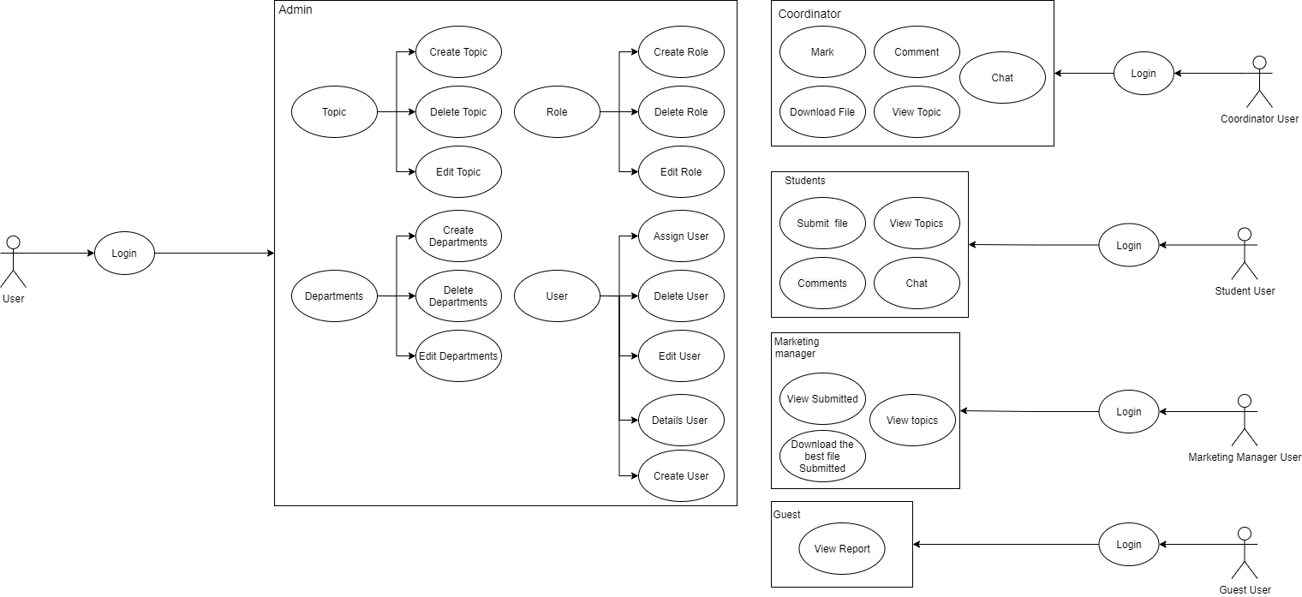

**Figure 2: Use Case Diagram**

**Admin:**

In the Admin panel, we can see that the admin can do in the project is to create Topic, create Role, create Department, create User. Creating the above functions to help Coordinator, Student and Marketing Manager easily manipulate and conveniently post documents, download documents, edit and delete documents that Admin has assigned in each account.

Admin can create Topics while creating Topics for Students and Coordinators they can edit, delete, and create new topics. In addition, Admin can create Roles, edit Roles and delete Roles to help the account decentralize clearly when logging in to each person. Avoid having a student's account be able to log into the coordinator or the coordinator to log into the marketing manager, ... Decentralize the account to avoid such risks. Admin can create Department, edit Department, delete Department, these are departments created by Admin to arrange for Student, Coordinator to know his Department. Finally, the Admin is the holder of all the accounts that the Admin has authorized and created. Holding these Users is for the convenience of the Admin to easily Assign, Delete, Edit, Detail, and Create the accounts that the Admin has created.

**Coordinator:**

The coordinator manager can review the Student's articles, download the Student's articles, evaluate, score, comment, download file on the Student's articles. These functions make the Coordinator's interaction with Students closer to give the best results for the lesson. The coordinator can choose the best student's lesson in that department to show the Marketing Manager and choose the best lesson in the department. Coordinator can Chat with Student about the article submitted in report file.

**Student:**

Student function can see his / her score after the Coordinator scores, Submit the article, Comment back to the teacher about the graded post. Discuss with Coordinator via Comment if the post has errors, you can View topics that Admin brought down to Student and Coordinator. After that the Student can Chat with Coordinator about the article submitted.

**Marketing Manager:**

Functions in this room include being able to download files that Student has submitted for review and evaluation. In addition, they also choose the best student work to honor and choose to do best in the department. This function only Marketing Manager and Coordinator know which post is the best post to be selected. Marketing Manager can view the topics that Admin has created.

**Guest:**

After login, the Guest can View Report of Student submitted

## **Activity Diagram:**

**Student:**

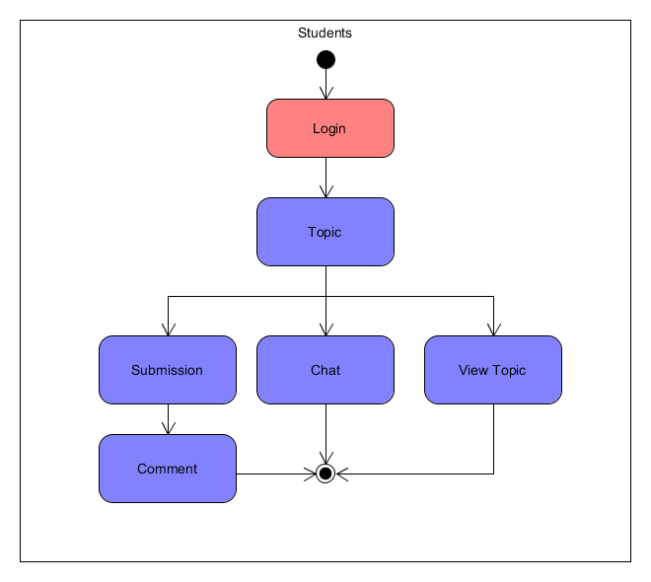

**Figure 3: Student Activity Diagram**

Diagram of student activities. To access the system students need to log into the account provided by the admin. When accessing successfully, students only have functions in Topic, students only have View Topic and are allowed to submit exam papers. Students can also comment on their work, and students can interact with Coordinator through the Chat function, ending the activity.

**Marketing:**

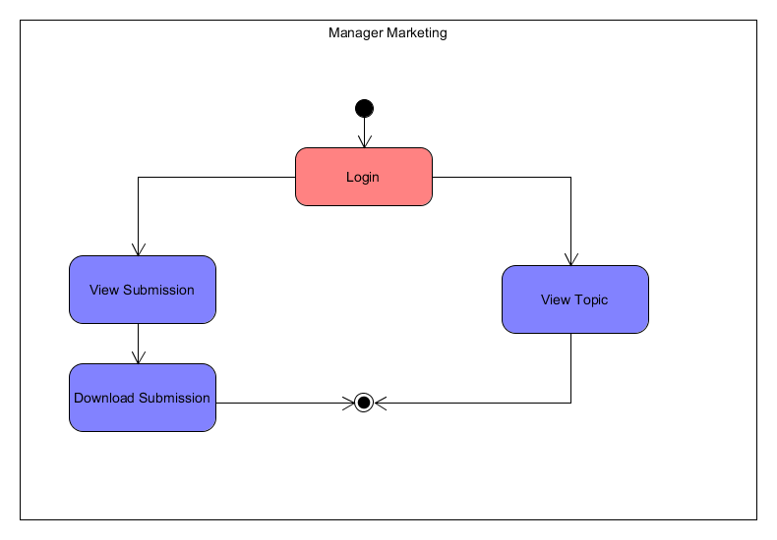

**Figure 4: Marketing Manager Activity Diagram**

Manage Marketing activity diagrams first need to login to the system, after successful login. Manage Marketing can select some student work and load student submissions and View Submission, to close the activity. Finally, the Marketing Manager can View the Topic from the system and finish the operation.

**Coordinator:**

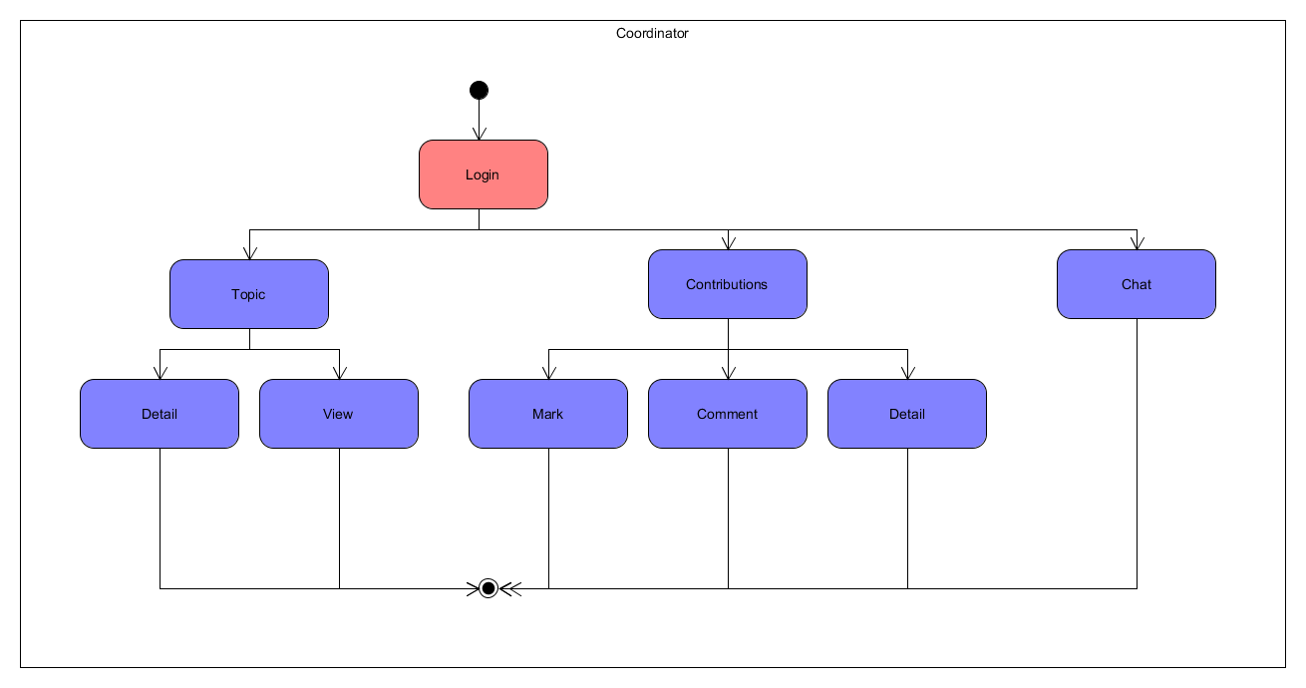

**Figure 5: Coordinator Activity Diagram**

The moderator activity chart is as follows, first to access the system, the coordinator needs an account to log into the system, after successful login consists of 2 parts: Topic and Contribution. Under Subject, the moderator has the function View Subject and Subject Detail, ending the activity. Contribute, the Coordinator can score student submissions, Comment on student submissions and possibly Contribute Details, the Coordinator can interact with students through the Chat function, ending the activity.

**Admin:**

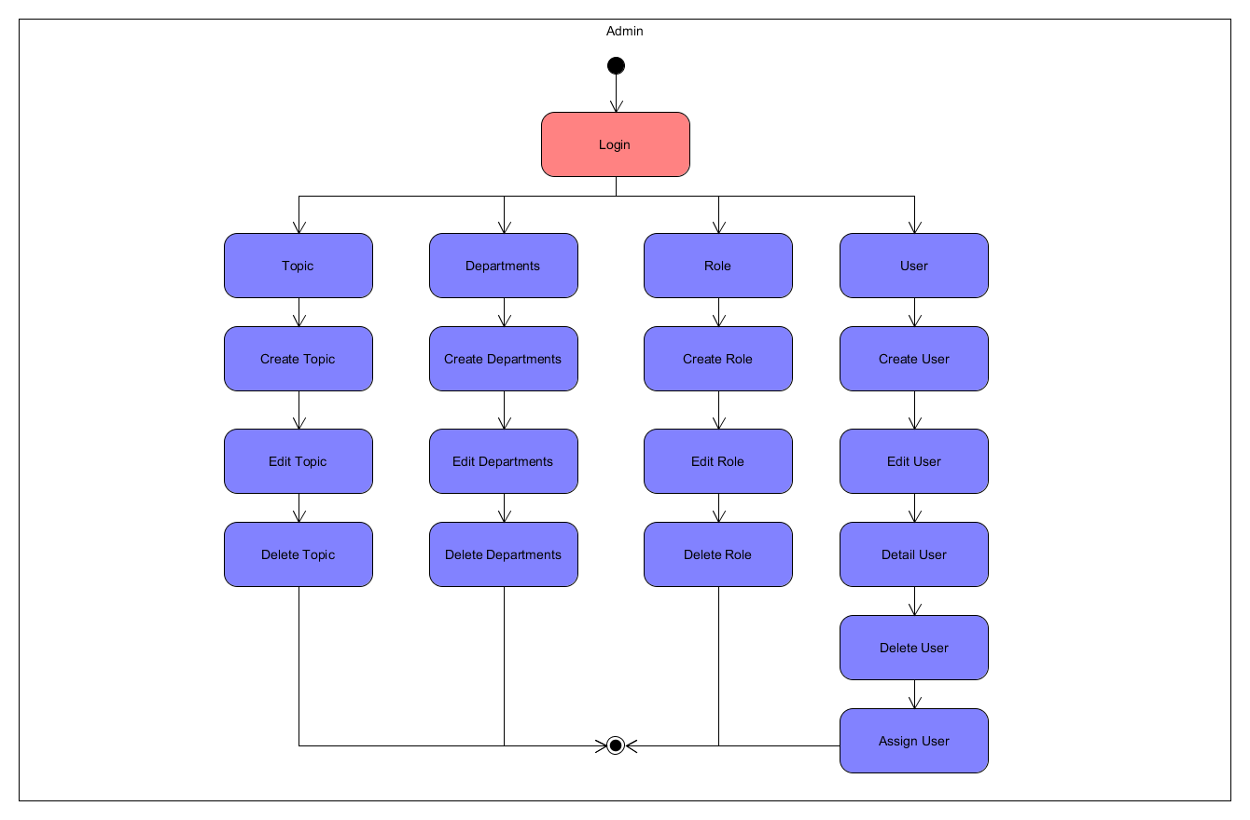

**Figure 6: Admin Activity Diagram**

In the admin activity diagram, in order to start accessing the admin system, it is necessary to log in with the admin's account. Once successfully logged in, the admin has access to the system. Admin will have 4 parts: Topic, Department, Role, and User. When the admin selects the Topic, the system will allow the admin to Create Topic, Edit Topic, and Delete Topic and finish the operation. Next, when the admin selects Departments, a similar Topic will also be Create, Edit, and Delete Department, ending the operation. Next, when the admin selects the Role section, this section has functions such as Topic and Department, Create, Edit and Delete, finishes the operation. Finally, in the User section, this admin can Create, Edit, Delete, Detail User and can Assign User, finish the operation.

**Guest:**

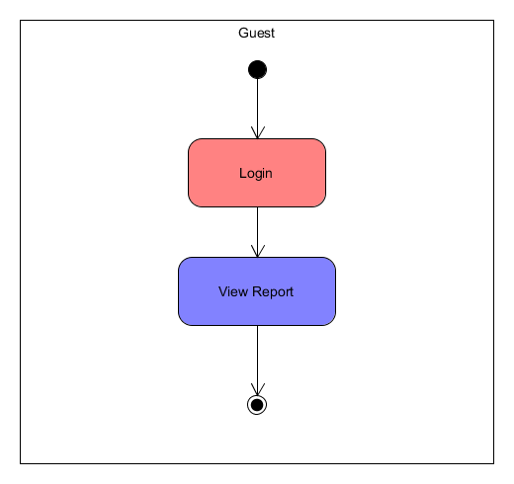

**Figure 7: Guest Activity Diagram**

Finally Guest's activity diagram. In order to access the guest system, you need to log into the system. In the system function of Guest can only View Report, finish the operation.

## **Sequence Diagram:**

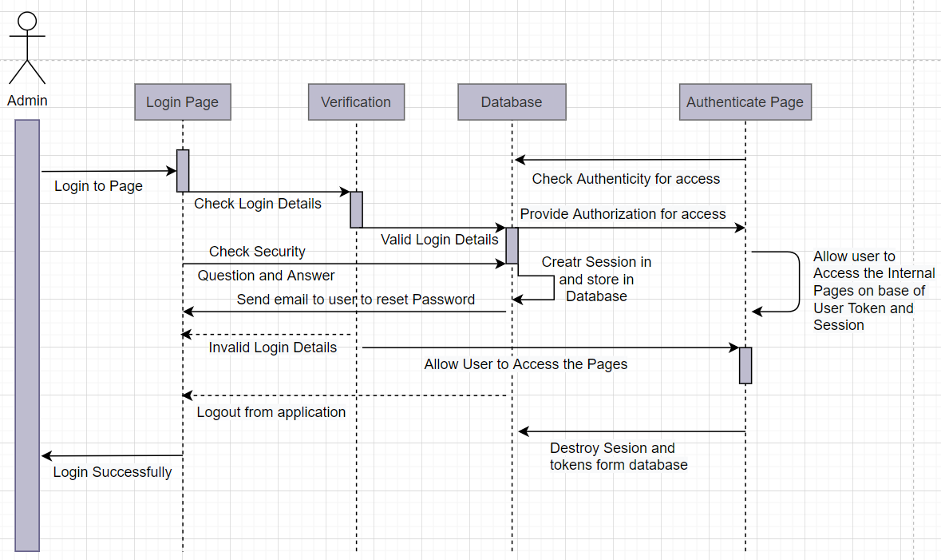

**Figure 8: Admin Sequence Diagram**

**Admin:**

With the Sequence Diagram that tells us that the Admin has a function when logging in, the first thing to do is verify that the Admin page has the correct account and role? If it is correct, then the Admin account is confirmed, otherwise, it will return to the login page and report an error where the login failed. After the verification is complete, the Admin goes to the Database of the website and all functions that the Admin can manage. After the admin can edit or upload the post, it will move to the verification of the page to be successful so that the Admin knows whether the method is correct or not. The Sequence Diagram gives us a better understanding of how the website behaves and the role the user plays on the site.

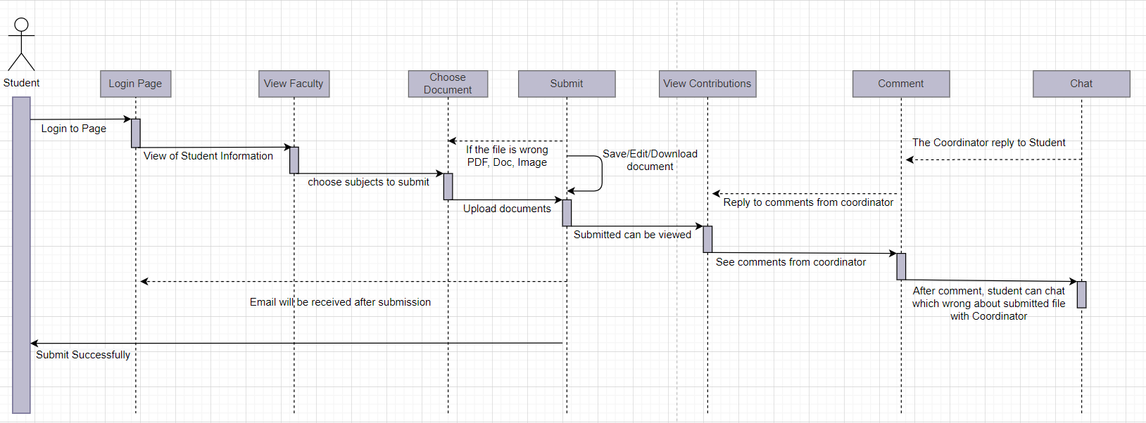

**Figure 9: Student Sequence Diagram**

**Student:**

The Student page, how the Sequence Diagram works, is similar to that of Admin, but about the Student, they can view their science, information about the faculty and choose the papers to submit, after submitting the papers, they can see the contributions. Comments from Coordinator and Marketing Manager to understand more about his post, they can chat together after comment. This allows students to interact more closely with teachers to lead to better results for students. The Student Sequence Diagram tells students how the student page works. The student and Coordinator can chat with together about file submitted.

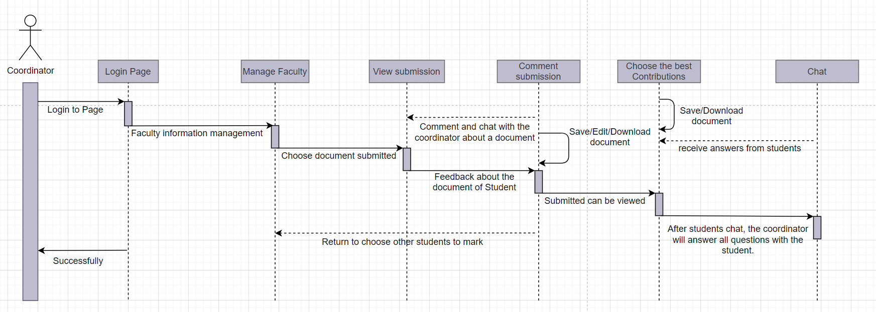

**Figure 10: Coordinator Sequence Diagram**

**Coordinator:**

About Coordinator, the login to the page is the same as other pages, but about the Coordinator in the Sequence Diagram, the first thing to do is to log in to the correct account assigned from the Admin. After logging in, the first thing the Coordinator needs is to manage departments, classes, and subjects. After selecting a faculty where students have submitted their papers, it is the most important thing that the Coordinator can see the student's submitted work. After reviewing the article, the Coordinator can comment and chat with Student on the post to show the interaction between the teacher and the student. The coordinator can download articles and choose the best post to send to the Marketing Manager to choose the best post. The post review, post comment, post-selection is complete, the page will return to the position to choose other faculties and other students so that the Coordinator can see.

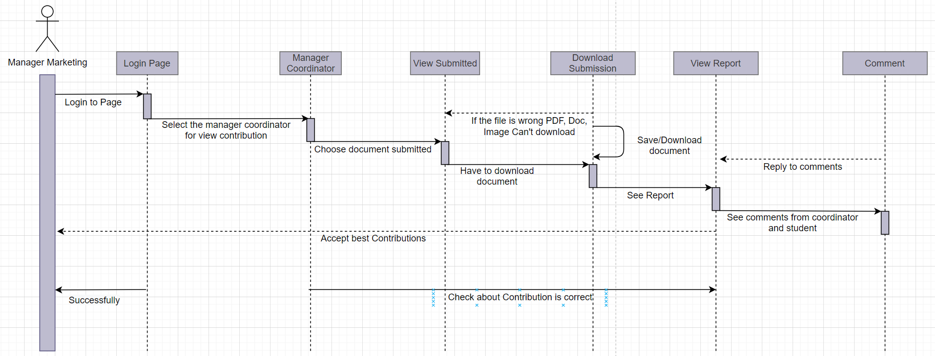

**Figure 11: Manager Marketing Sequence Diagram**

**Manager Marketing:**

When the Marketing Manager logs on to the page, they can view the articles that the students have submitted so they can view and download them, so they can choose the best lesson. Manager Marketing can see the report between Coordinator and Student so that they better understand the content between the two people discussing to understand about the student's post submitted. After selecting the appropriate articles, the Marketing Manager will return to the articles of the other faculties to choose the good articles of the other faculties.

**Guest:**

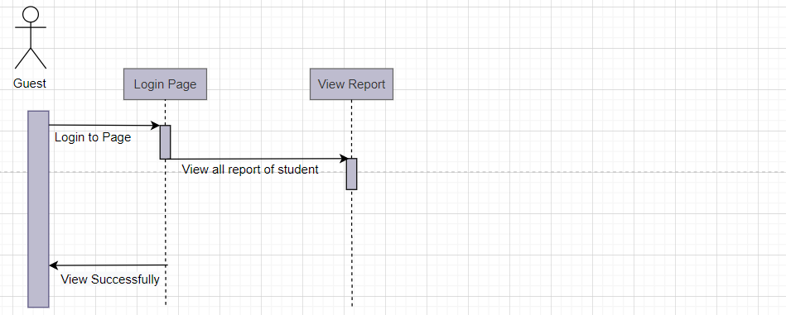

**Figure 12: Guest Sequence Diagram**

Guest, after logging into the page, Guest can only view Student reports on submission.

|  |  |  |
| --- | --- | --- |
| **Use case name:**  Login | **ID:**  UC1 | **Priority:** High |
| **Actor:**  Admin, Coordinator, Marketing Manager, Student, Guest | | |
| **Brief description:**  A user logs in to the system to access the functionality of the system. | | |
| **Trigger:**  Document Management User has reached a point in their workflow in which a document is to be generated.  **Type : External Temporal** | | |
| **Normal Course:**  1.When users access the system, the login page will be displayed  2.If the user does not have an account, the admin will create an account for the user  3. If you log in more than the specified number of times, the system will support Forgot password for users to get an account back.  4. After logging in to the system, users use the function in the system. | **Information for Steps** | |
| **Post conditions:** Successfully : Login successfully, the user accesses the system  Cannot Login : Login failed, user cannot access the system | | |

|  |  |  |
| --- | --- | --- |
| **Use case name:**  Create Topics / Department / Role / User | **ID:**  UC2 | **Priority:** High |
| **Actor:**  Admin | | |
| **Brief description:**  Create Topics / Department / Role / User | | |
| **Trigger:**  Document Management User has reached a point in their workflow in which a document is to be generated.  **Type : External Temporal** | | |
| **Normal Course:**  1. When accessing the system, Admin needs to log into the system  2. Admin wants to Create a Topic/ Department / Role / User, Admin needs to enter full information such as ID, Name, Description, ...  3. The system will confirm and check the information entered by the Admin and create the Topic / Department / Role / User as requested by the Admin.  4. If the Topic / Department / Role / User already exists, the system will notify the administrator that exists in the system.  5. If it does not exist in the system, then the system will create the Topic / Department / Roles / Users according to the information provided by the Admin. | **Information for Steps** | |
| **Post conditions:**  Successfully : The system will create successful Topic / Department / Role / User  Cannot create: Admin has entered invalid data or already exists in the system. In either case, Topci / Department / Role / User will not be created on the system. | | |

|  |  |  |
| --- | --- | --- |
| **Use case name:**  Edit Topics / Department / Role / User | **ID:**  UC3 | **Priority:** High |
| **Actor:**  Admin | | |
| **Brief description:**  Admin can Edit Topics / Department / Role / User | | |
| **Trigger:**  Document Management User has reached a point in their workflow in which a document is to be generated.  **Type : External Temporal** | | |
| **Normal Course:**  1.Admin enters the Topic / Department / Role / User information admin want to edit like Id, Name, Email, ...  2. The system will confirm the admin information entered and check if it exists in the system or not.  3. If it exists, the system will inform Admin with full information about the Topic / Department / Role / User that the admin wants to edit.  4. Use the ending shift | **Information for Steps** | |
| **Post conditions:**  Successfully : Admin has successfully edited Topic / Department / Role / User information  Cannot edit : Admin has entered invalid or nonexistent data in the system. In either case, the Admin will not be able to edit the Topic / Department / Roles / Users on the system | | |

|  |  |  |
| --- | --- | --- |
| **Use case name:**  Delete Topic / Department / Role / User | **ID:**  UC4 | **Priority:** High |
| **Actor:**  Admin | | |
| **Brief description:**  Admin can Delete Topic / Department / Role / User | | |
| **Trigger:**  Document Management User has reached a point in their workflow in which a document is to be generated.  **Type : External Temporal** | | |
| **Normal Course:**  1. Admin enters the information Topic / Department / Role / User to delete such as Name, Id, Email, ...  2. The system will check and confirm the information of Topic / Department / Role / User exists in the system or not.  3. If it exists, the system will notify the Admin that the Topic / Department / Role / Admin user that you want to delete has been deleted  4. The use case ends. | **Information for Steps** | |
| **Post conditions:**  Successfully : Admin has successfully deleted Topic / Department / Roles / Users in the system  Cannot delete: Admin entered invalid or nonexistent data in the system. In either case, Admin will not be able to delete Topic / Department / Roles / Users in the system | | |

|  |  |  |
| --- | --- | --- |
| **Use case name:**  Detail User / Topic | **ID:**  UC5 | **Priority:** High |
| **Actor:**  Admin | | |
| **Brief description:**  Admin can Detail User / Topic | | |
| **Trigger:**  Document Management User has reached a point in their workflow in which a document is to be generated.  **Type : External Temporal** | | |
| **Normal Course:**  1.Admin enter the information of the User / Topic they want to View Details such as Name, Id, Email, ...  2. The system will confirm and search whether the information exists in the system or not.  3. If it exists, the system will notify the Admin that the User / Topic you want to View Details  4. The use case ends. | **Information for Steps** | |
| **Post conditions:**  Successfully : Admin has successfully View User Details / Topic  Cannot view details: Admin entered data is invalid or does not exist in the system. In either case, it is not possible to see any User / Topic details in the system | | |

|  |  |  |
| --- | --- | --- |
| **Use case name:**  Assign User | **ID:**  UC6 | **Priority:** High |
| **Actor:**  Admin | | |
| **Brief description:**  Admin can Assign User | | |
| **Trigger:**  Document Management User has reached a point in their workflow in which a document is to be generated.  **Type : External Temporal** | | |
| **Normal Course:**  1. Admin needs to enter the information of the user that needs Assign such as Name, Id, Email, ...  2. The system will confirm and check for user information that exists in the system or not.  3. If the user still exists, the system will notify the Admin that the user want to Assign  4. The use case ends. | **Information for Steps** | |
| **Post conditions:**  Successfully : The admin successfully Assign user  Cannot Assign user: Admin has entered invalid or nonexistent user information data in the system. In either case, Admin cannot be Assign user in the system | | |

|  |  |  |
| --- | --- | --- |
| **Use case name:**  View Topic | **ID:**  UC7 | **Priority:** High |
| **Actor:**  Coordinator, Student, Manage Marketing | | |
| **Brief description:**  Coordinator, Student, Manage Marketing can View Topic | | |
| **Trigger:**  Document Management User has reached a point in their workflow in which a document is to be generated.  **Type : External Temporal** | | |
| **Normal Course:**  1. Student / Coordinator / Marketing Manager enter the topic information they want to see such as Id, Name, ...  2. The system will confirm and check whether the information exists in the system or not.  3.If exists, the system will inform the Student / Coordinator / Marketing Manager of full information about the topic want to view.  4. Use the ending shift | **Information for Steps** | |
| **Post conditions:**  Successfully : Student / Coordinator / Manage Marketing successfully view Topic  Cannot view Topic : Student / Coordinator / Manage Marketing entered invalid data or Topic does not exist in the system. In either case, the Topic will not be able to be viewed | | |

|  |  |  |
| --- | --- | --- |
| **Use case name:**  Comment Topic | **ID:**  UC8 | **Priority:** High |
| **Actor:**  Coordinator, Student | | |
| **Brief description:**  Coordinator / Student can Comment Topic | | |
| **Trigger:**  Document Management User has reached a point in their workflow in which a document is to be generated.  **Type : External Temporal** | | |
| **Normal Course:**  1. Students / Coordinators enter the submission information they want to Comment such as Id, Name, ...  2. The system will confirm and check whether the submitted profile information still exists or not.  3. If the submission exists, the system will notify the Student / Coordinators who will be commented on the student's submission on the system.  4. Use the ending shift | **Information for Steps** | |
| **Post conditions:**  Successfully : Student / Coordinator Comment submission successfully  Cannot Comment: Student / Coordinator entered invalid data or the submission does not exist in the system. In either case, cannot Comment submission | | |

|  |  |  |
| --- | --- | --- |
| **Use case name:**  Detail Contribution | **ID:**  UC9 | **Priority:** High |
| **Actor:**  Coordinator | | |
| **Brief description:**  Coordinator can Detail Contribution | | |
| **Trigger:**  Document Management User has reached a point in their workflow in which a document is to be generated.  **Type : External Temporal** | | |
| **Normal Course:**  1.Coordinator enter the information of the Contribution you want to View Details such as Name, Id, Email, ...  2. The system will confirm and search whether the information exists in the system or not.  3. If it exists, the system will notify the Coordinator that the Contribution you want to View Details  4. The use case ends. | **Information for Steps** | |
| **Post conditions:**  Successfully : Coordinator has been successful Detail Contribution  Cannot Detail: The Coordinator entered invalid data or the Contribution does not exist. In either case, Coordinator failed to Detail Contribution. | | |

|  |  |  |
| --- | --- | --- |
| **Use case name:**  Submit | **ID:**  UC10 | **Priority:** High |
| **Actor:**  Student | | |
| **Brief description:**  Student can Submit | | |
| **Trigger:**  Document Management User has reached a point in their workflow in which a document is to be generated.  **Type : External Temporal** | | |
| **Normal Course:**  1. Students enter information topics to submit such as Id, Name, ...  2. The system will confirm and check whether the topic information exists or not.  3. If there is a Topic, the system will send students to submit the article to the system.  4. Use the ending shift | **Information for Steps** | |
| **Post conditions:**  Successfully : Students can submit article successfully  Cannot Submit: Student entered invalid data, Topic does not exist or does not qualify for submitting and the deadline has expired. In the above case, students cannot submit their article to the system | | |

|  |  |  |
| --- | --- | --- |
| **Use case name:**  Mark | **ID:**  UC11 | **Priority:** High |
| **Actor:**  Coordinator | | |
| **Brief description:**  Coordinator can Mark | | |
| **Trigger:**  Document Management User has reached a point in their workflow in which a document is to be generated.  **Type : External Temporal** | | |
| **Normal Course:**  1. Coordinator input the contribution information that wants to Mark as Id, Name, ...  2. The system will confirm and check whether the information exists in the system or not.  3.If the contribution exists, the Coordinator will be Mark for that contribution  4. Use the ending shift | **Information for Steps** | |
| **Post conditions:**  Successfully : The Coordinator has Mark contributions successful  Cannot Mark: Coordinator entered invalid data or the contribution does not exist. In either case, the Coordinator will not be Mark | | |

|  |  |  |
| --- | --- | --- |
| **Use case name:**  Download File | **ID:**  UC12 | **Priority:** High |
| **Actor:**  Manage Marketing | | |
| **Brief description:**  Manage Marketing can Download File | | |
| **Trigger:**  Document Management User has reached a point in their workflow in which a document is to be generated.  **Type : External Temporal** | | |
| **Normal Course:**  1. The Marketing Manager enters the submission information of students that want to Download such as Id, Name, ...  2. The system will confirm and check the submission information exists or not.  3.If the submission still exists, the system will notify the Marketing Manager to Download all file it as a Zip file.  4. Use the ending shift | **Information for Steps** | |
| **Post conditions:**  Successfully : The Manager Marketing downloads all of the successful student submissions  Cannot download: Manager Marketing, entered invalid data, or submission content does not exist. In either case, the Manager Marketing cannot be downloaded | | |

|  |  |  |
| --- | --- | --- |
| **Use case name:**  View Report | **ID:**  UC13 | **Priority:** High |
| **Actor:**  Guest | | |
| **Brief description:**  Guest can View Report | | |
| **Trigger:**  Document Management User has reached a point in their workflow in which a document is to be generated.  **Type : External Temporal** | | |
| **Normal Course:**  1. Guests must be logged into the system to view reports  2. The system will display the reports  3. Use the ending shift | **Information for Steps** | |
| **Post conditions:**  Successfully : Guest has successfully View Report  Cannot View Report: Report is not updated or does not exist | | |

|  |  |  |
| --- | --- | --- |
| **Use case name:**  Chat | **ID:**  UC14 | **Priority:** High |
| **Actor:**  Coordinator / Student | | |
| **Brief description:**  Coordinator / Student can Chat | | |
| **Trigger:**  Document Management User has reached a point in their workflow in which a document is to be generated.  **Type : External Temporal** | | |
| **Normal Course:**  1. Students / Coordinator want to interact, click on the Chat function  2. The system will display Chat frame, and user will create a Chat rooms according to Topic  3. People related to that Topic can Chat  4. Use the ending shift | **Information for Steps** | |
| **Post conditions:**  Success: Coordinator / Student Chat successfully  Cannot Chat: Coordinator / Student cannot Chat because Chats rooms have not been created yet | | |

# V. Design

**Home page:**

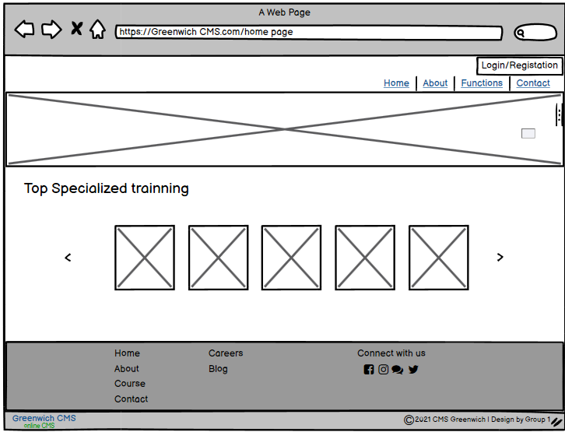

**Figure 13: Home page**

**Sign in page:**

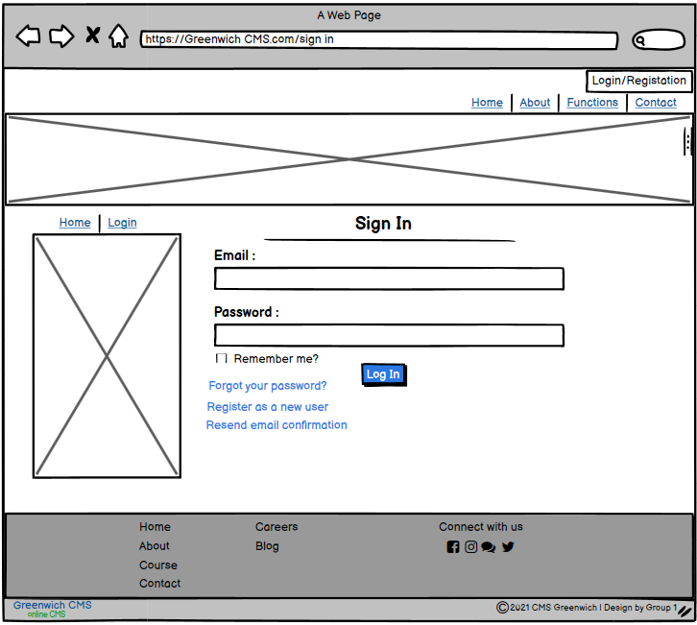

**Figure 14: Sign in page**

**Sign Up page:**

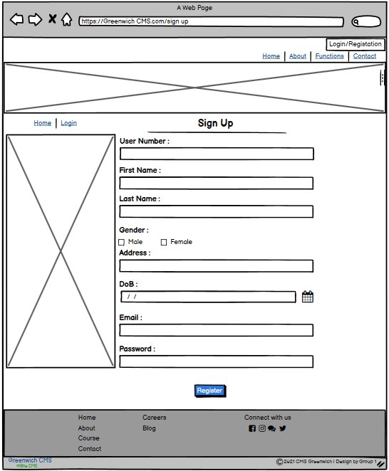

**Figure 15: Sign Up page**

**Admin User page:**

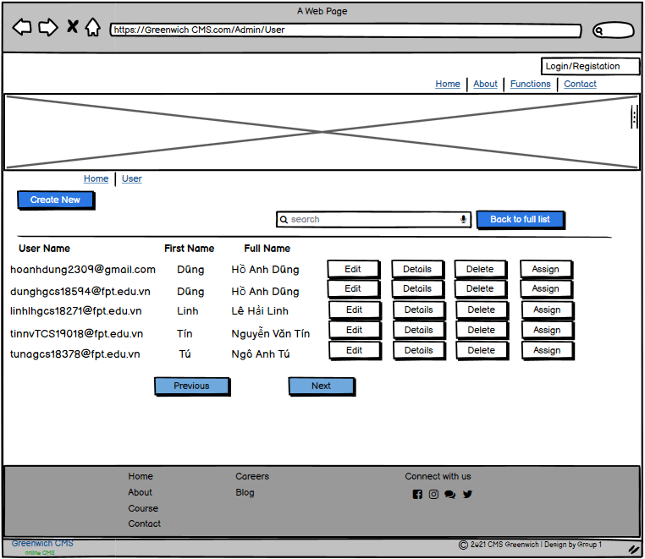

**Figure 16: Admin User page**

**Admin Assign Role page:**

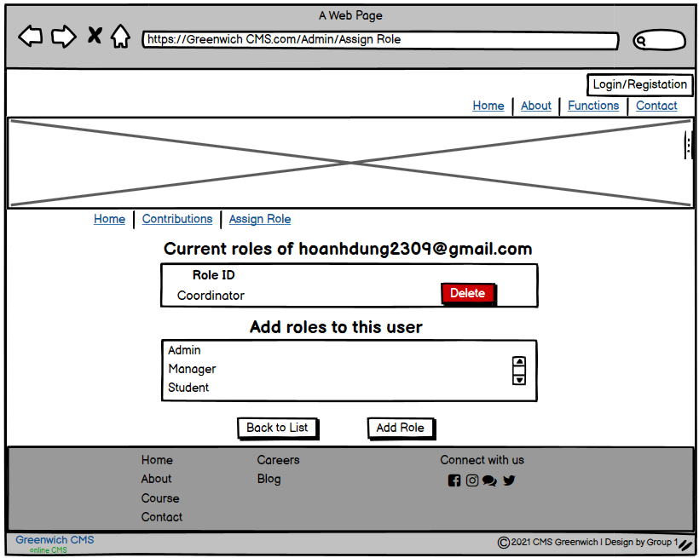

**Figure 17: Admin Assign Role page**

**Admin Role page:**

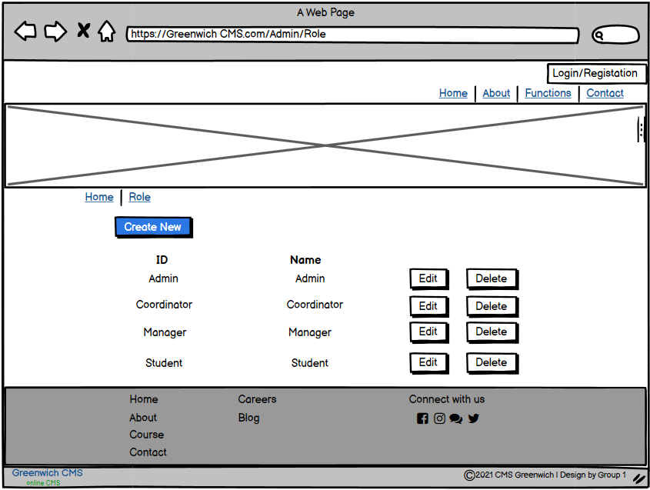

**Figure 18: Admin Role page**

**Admin topic:**

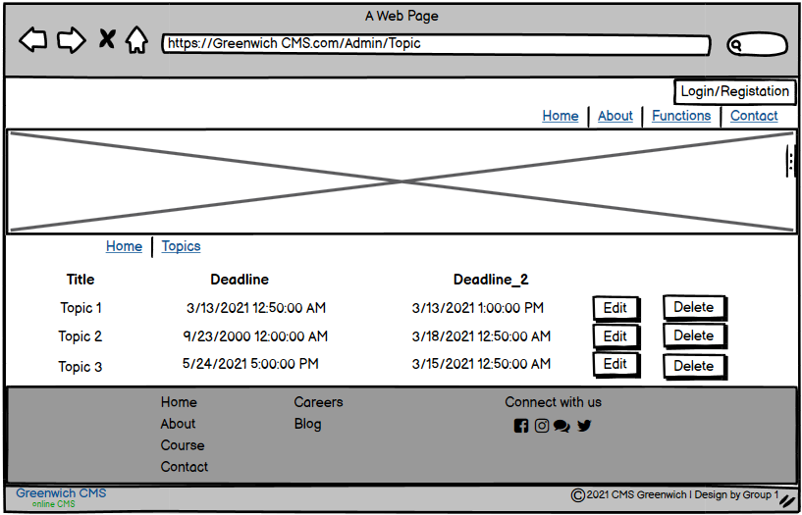

**Figure 19: Admin topic**

**Admin Department:**

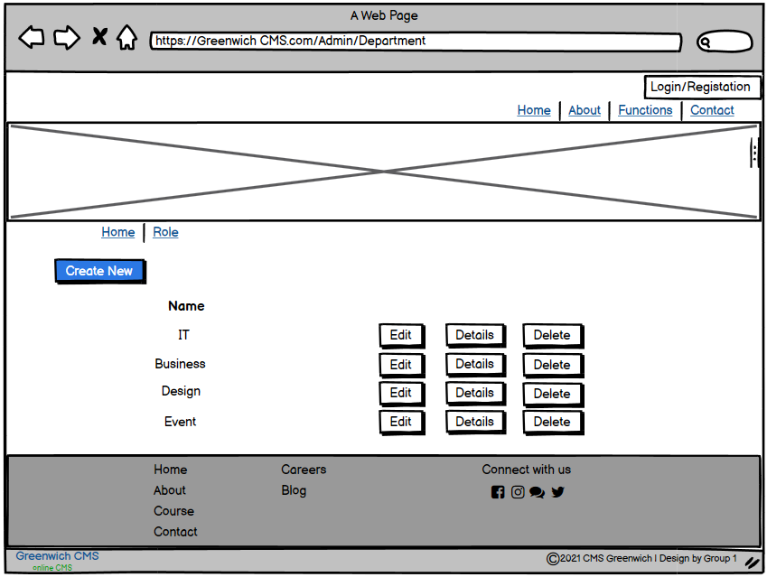

**Figure 20: Admin Department**

**Coordinator Topic:**

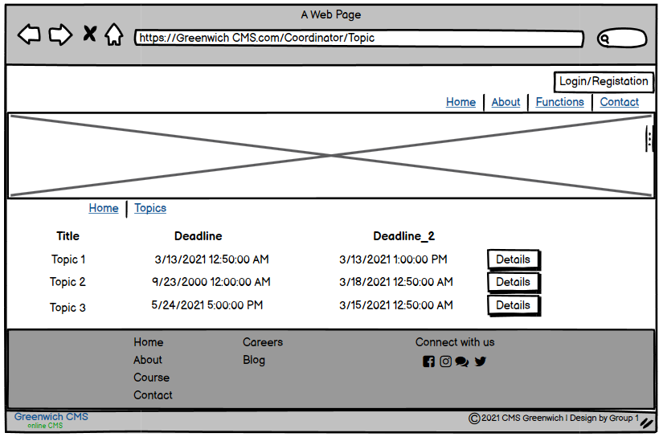

**Figure 21: Coordinator Topic**

**Coordinator Contributions:**

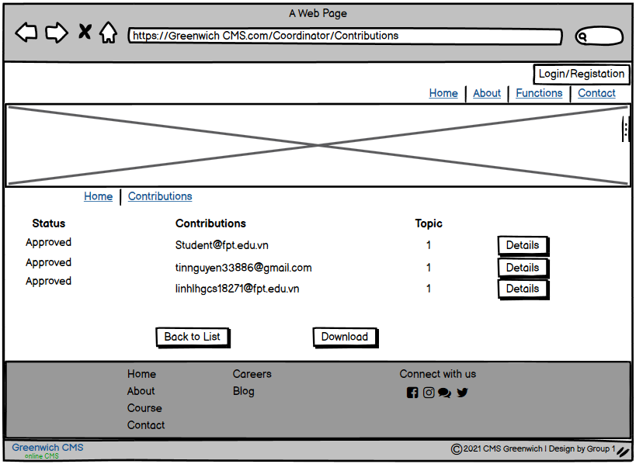

**Figure 22: Coordinator Contributions**

**Coordinator Details:**

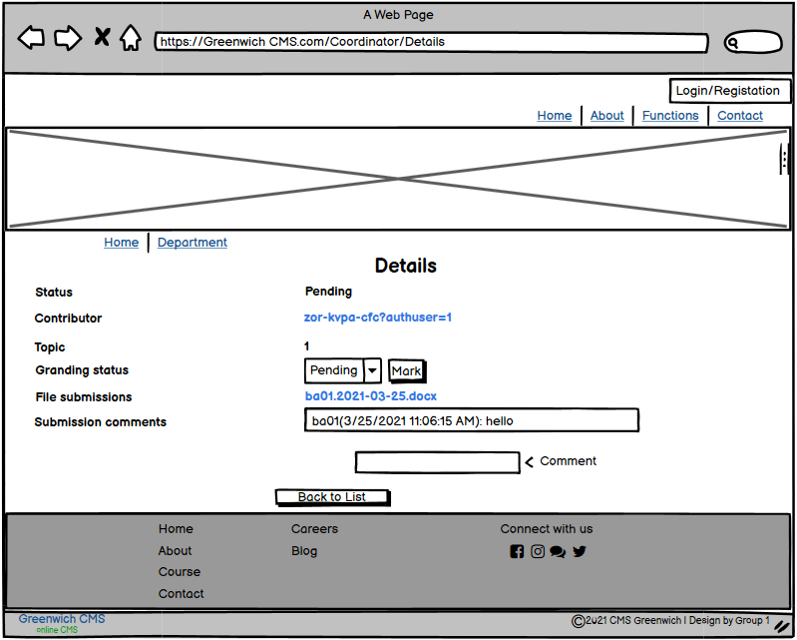

**Figure 23: Coordinator Details**

**Student topic:**

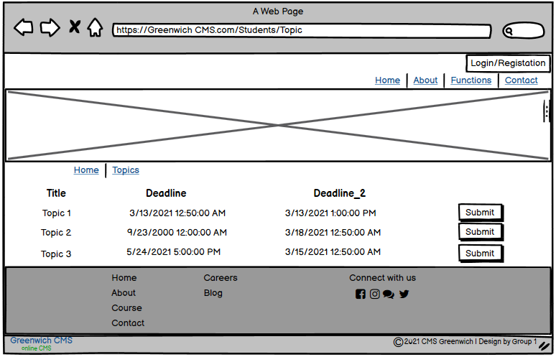

**Figure 24: Student topic**

**Marketing manager topic:**

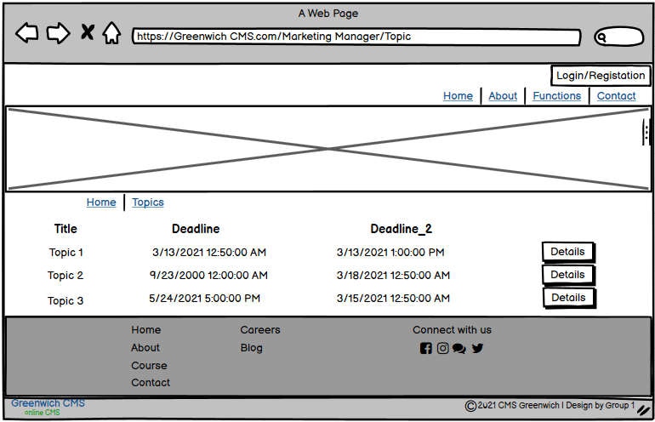

**Figure 25: Marketing manager topic**

**Marketing manager Contribution:**

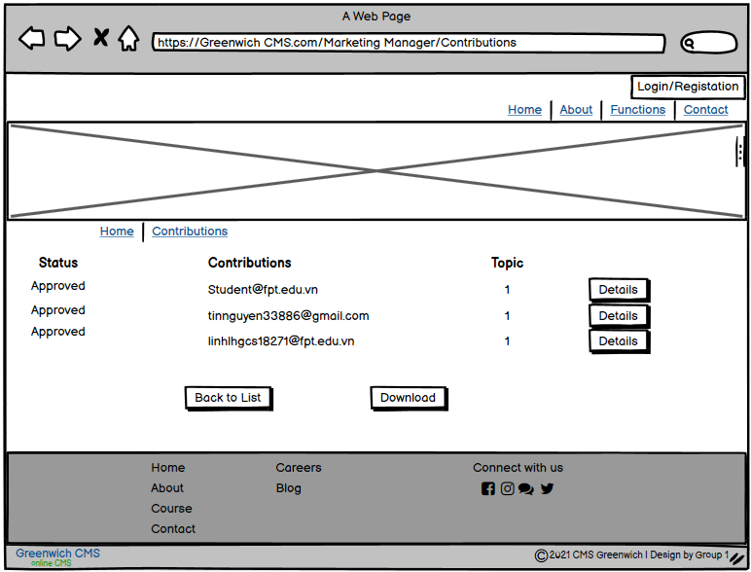

**Figure 26: Marketing manager Contribution**

**Admin Department:**

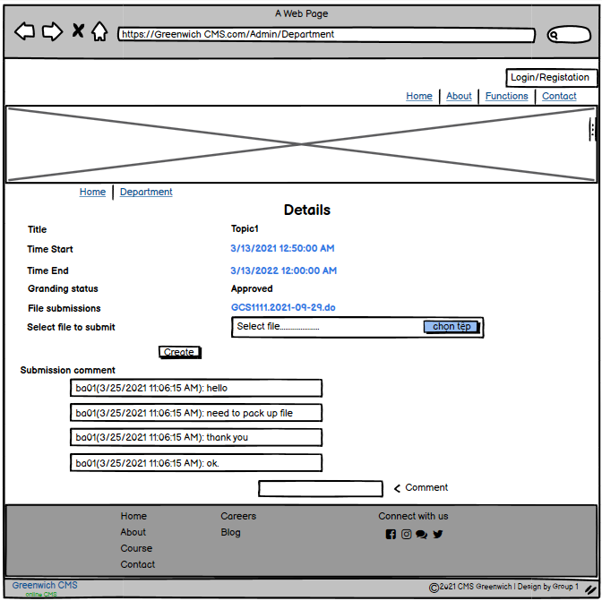

**Figure 27: Admin Department**

**About:**

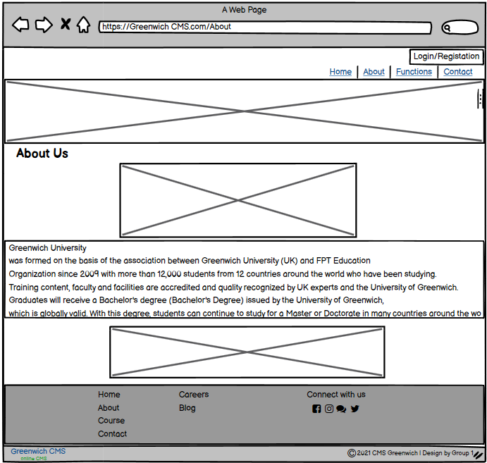

**Figure 28: About**

**Campus location:**

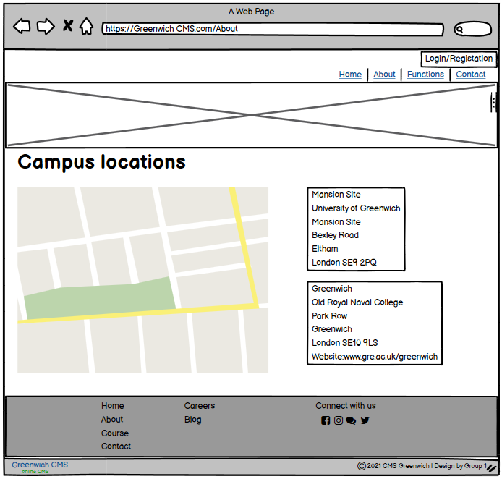

**Figure 29: Campus location**

**Report:**

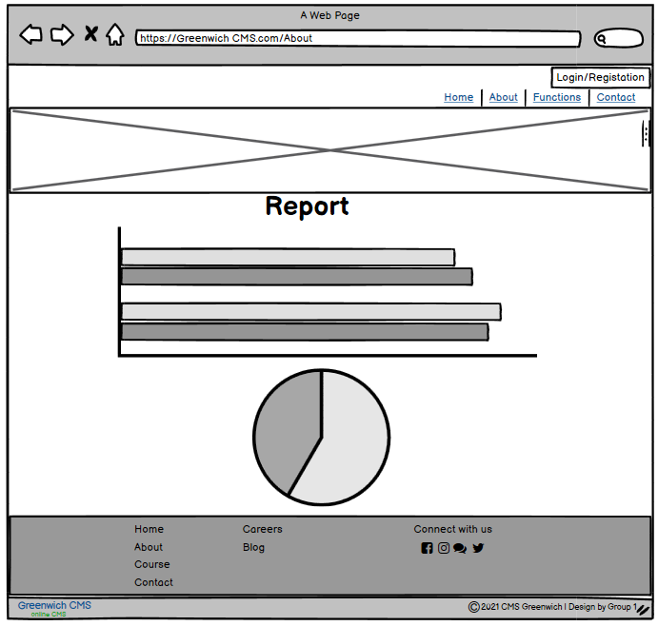

**Figure 30: Report page**

**Chat Box:**

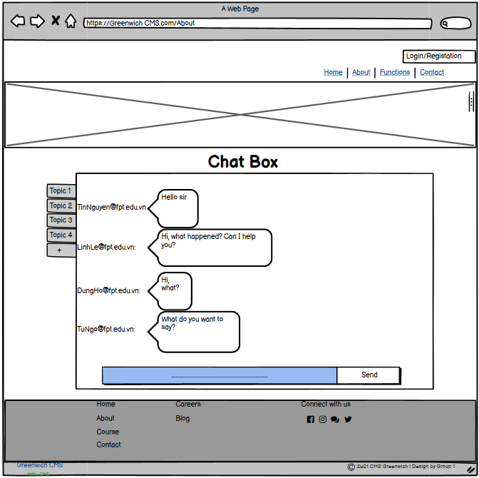

**Figure 31: Chat box**

# VI. Testing

## **Test Plan:**

|  |  |  |  |  |  |
| --- | --- | --- | --- | --- | --- |
| **No** | **Method** | **How to test** | **Desired results** | **Testing** | **Result** |
| 1 | Login | Enter Username and Password  and click “Sign in” button in Admin page | Login successfully | Fail | Success |
| 2 | Logout | Click “Log out” button in Admin page | Logout successfully | Fail | Success |
| 3 | Create new account | Click “Create” button in Admin page | The account was created by Admin | Success | Success |
| 4 | Details user account | Click the "Details" button in each account in Admin page | Show details of the selected account by Admin | Success | Success |
| 5 | Edit user information | Click “Edit” button in User in Admin page | Edit information in Database | Success | Success |
| 6 | Delete user account | Click “Delete” button in User in Admin page | Delete account in Database | Success | Success |
| 7 | Assign User account | Click “Assign” button in User in Admin page | Choose role account | Fail | Success |
| 8 | Create Roles | Click ”Create” button in Role in Admin pages | The roles was created by Admin | Fail | Success |
| 9 | Edit Roles | Click ”Edit” button in Role in Admin pages | Edit roles in Database | Fail | Success |
| 10 | Delete Roles | Click ”Delete” button in Role in Admin pages | Delete roles in Database | Fail | Success |
| 11 | Add Roles User | Click ”Edit Role” button in Manager User pages of Admin pages | Add roles for user | Fail | Success |
| 12 | Create Topic | Click “Create” button in Topic in Admin page | Create Topic in Database | Success | Success |
| 13 | Edit Topic | Click “Edit” button in Topic in Admin page | Edit Topic in Database | Success | Success |
| 14 | Delete Topic | Click “Delete” button in Topic in Admin page | Delete Topic | Success | Success |
| 15 | Delete Department | Click “Delete” button in Department in Admin page | Delete Department in Database | Success | Success |
| 16 | Create Department | Click “Create” button in Department in Admin page | Create Department in Database | Success | Success |
| 17 | Edit Department | Click “Edit” button in Department in Admin page | Edit Department in Database | Success | Success |
| 18 | View Topic | Click “View” button in Coordinator page | View about Topic in Database | Success | Success |
| 19 | Detail Topic | Click “Detail” button in Coordinator page | Detail Topic in Database | Success | Success |
| 20 | Comment | Click “Comment” button in Coordinator page | Comment about whatever to Student | Fail | Success |
| 21 | Mark | Click “Mark” button in Coordinator page | To dot point for student | Fail | Success |
| 22 | Detail Contribution | Click “Detail” button in Coordinator page | Input to see about detail | Success | Success |
| 23 | View Topic | Click “View” button in Student page | See about Topic in this page | Success | Success |
| 24 | Comment | Click “Comment” button in Student page | Comment back to the Coordinator | Fail | Success |
| 25 | Submission | Click “Submit” button in Student page | To submit the exercise to the page | Fail | Success |
| 26 | View Topic | Click “View” button in Marketing Manager page | View about Topic | Success | Success |
| 27 | Download File | Click “Download” button in Marketing Manager page | To download file in the lesson the student has submitted | Fail | Success |
| 28 | Choose the best file Submit | Click “Choose” button in Marketing Manager page | Choose the best file in the lesson the student has submitted | Success | Success |
| 29 | View file | Click “View” button in Guest page | The Guest can see about view file | Success | Success |
| 30 | Chat | Click “Chat” button in Student, Coordinator, Manager Marketing page | Everyone can chat together about report file | Fail | Success |

## **Test Log:**

For the system to work properly we need to test it first to find out if the system has any problems. We test the system as follows:

**Interface**

Test the interface to verify that communication between two different software systems is properly implemented in the project. Interfaces consist of software, command sets, messages, and other properties that allow the user and the device to communicate with each other. For testing the interface include:

* Communication between the system server and the user server
* Communication between the user server and the database

Checking the interface will help the system check whether the server is executing properly as the project does, will detect some errors and fix it in time.

**Database**

The database part is very important to the system because it decides whether to store information or not, so when the system is complete we need to check the database by 3 main part :

* Structure: is the inspection of data about inside the data warehouse. In this section tests include Schema Inspection, Table and Column Inspection, Keys and Indexes, Stored Process, Activation Verification, and Database Server Authentication
* Functionality: verification of user functional requirements and data integrity and consistency, User Login and Security
* Non-functional: must check on the occurrence of the risk to help stakeholders determine requirements. The system needs to be configured correctly to be efficient enough

We check so for the purpose that all user information stored in the system is correct and valid and avoid data theft

**Security test**

Security testing to detect vulnerabilities and risks of the system to prevent an attack on the system. For security testing we will use a number of tools to check for vulnerabilities to see if the system detects the vulnerabilities to avoid penetration. Finally, we will evaluate risks from Low - Medium - High to identify risks and propose measures. To increase the security of the system, we will encrypt passwords in an encrypted format. The system does not allow invalid users to access.

**Compatibility test**

Compatibility testing to test non-functionalities, to see if the system is compatible with all platforms, operating systems, .. or not. The system may affect different versions and configurations so the system will not function smoothly.

* Check your system hardware for compatibility with other configurations.
* Check the system is compatible with operating systems such as Windows, Mac, ...
* Check the Network to evaluate the system works with information such as Speed, Capacity and compatible with other networks such as Wifi, 4G, ...
* Checking the software version is essential. It helps us to know what software version the system is compatible with

The compatibility test is for the system to work for all platforms, we can test the system on another and find bugs in the system

# VII. Agile Method:

## **Produce Backlogs:**

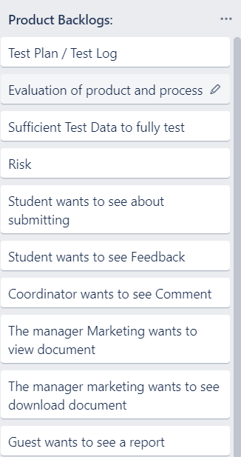

**Figure 32: Produce Backlogs**

**Sprint 1 2:**

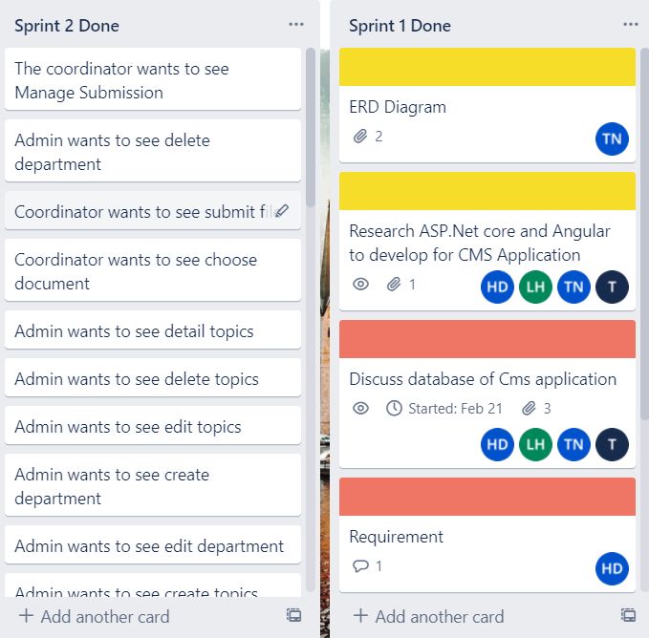

**Figure 33: Sprint 1 2**

## **In Progress:**

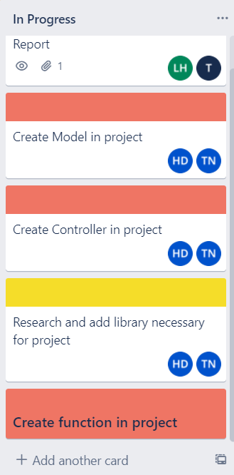

**Figure 34: In Progress**

## **Daily Meeting:**

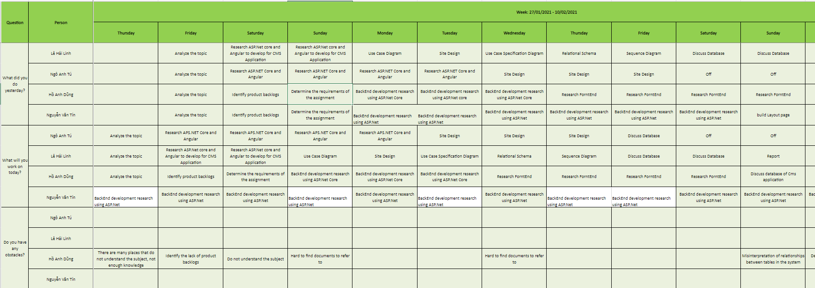

**Figure 35: Daily Meeting**

**Sprint Review & Retrospective Meetings:**

## **Burndown Charts**

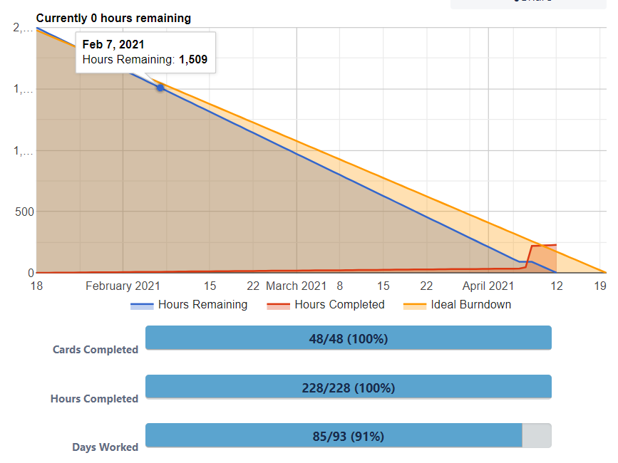

**Figure 36: Burndown chart**

# VIII. Product:

**Index page:**

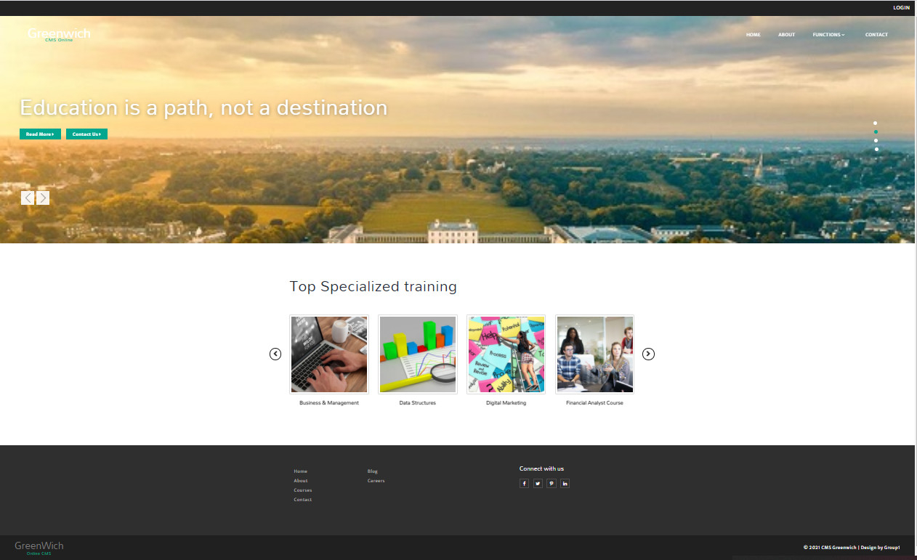

**Figure 37: Index page**

**About page:**

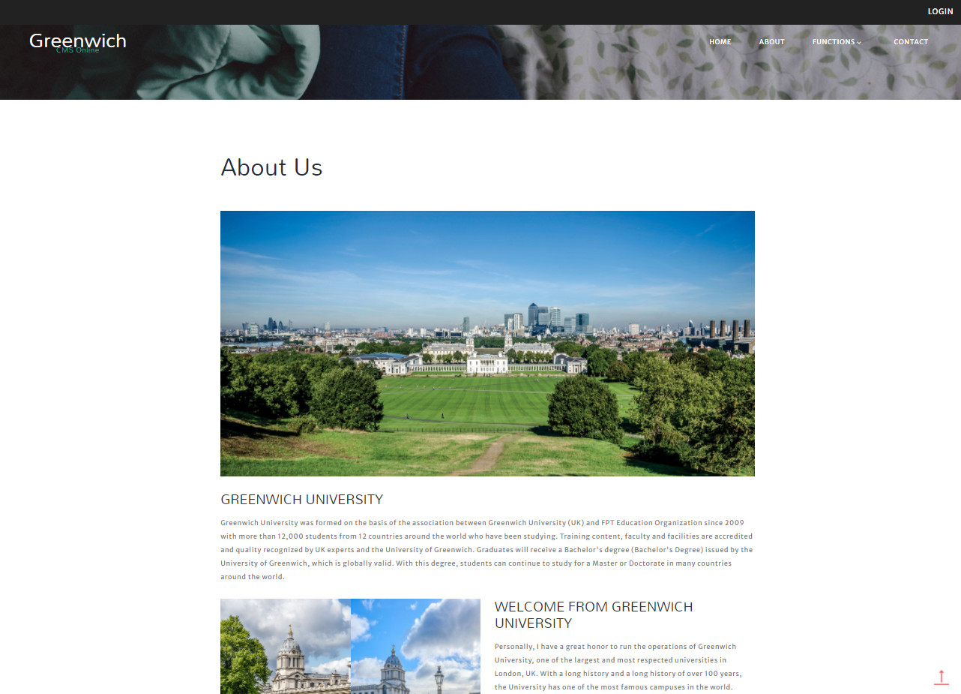

**Figure 38: About page**

**Contact page:**

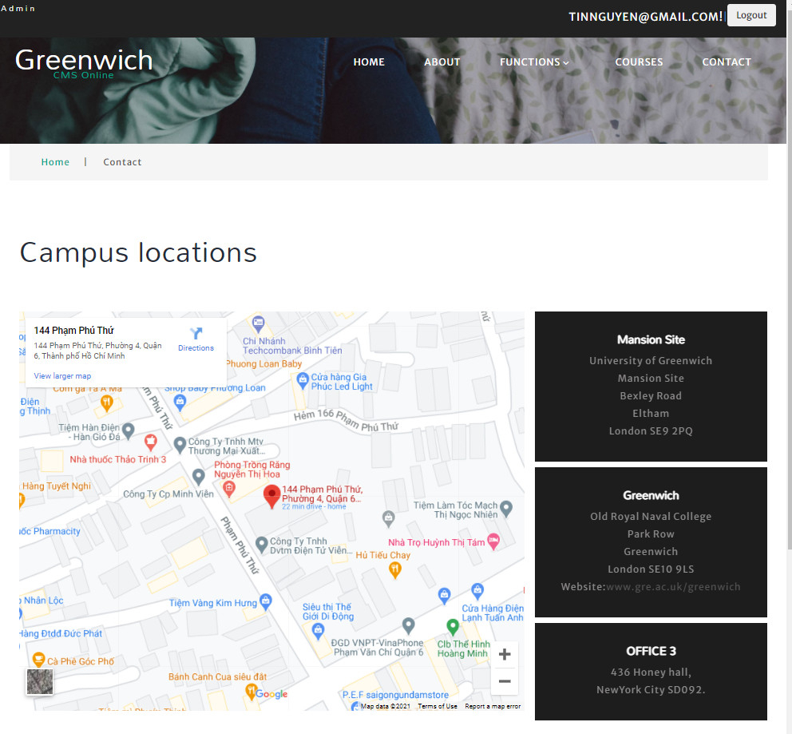

**Figure 39: Contact page**

**Login page:**

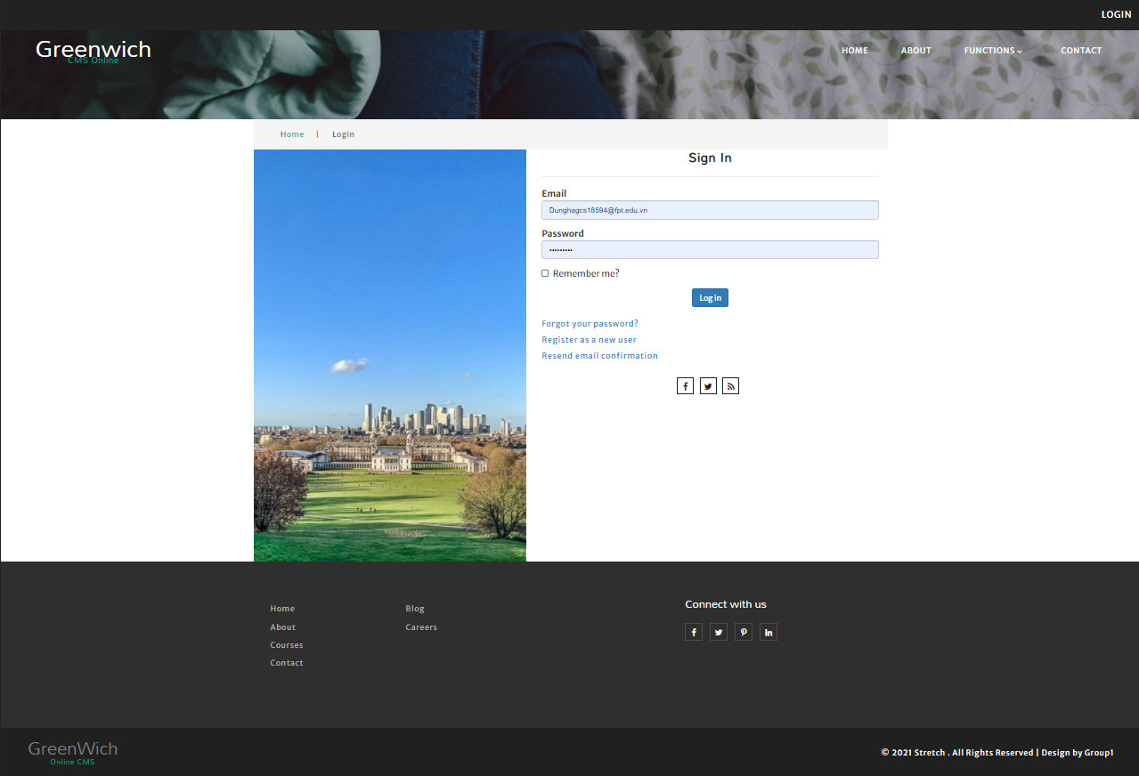

**Figure 40: Login page**

**Registration page:**

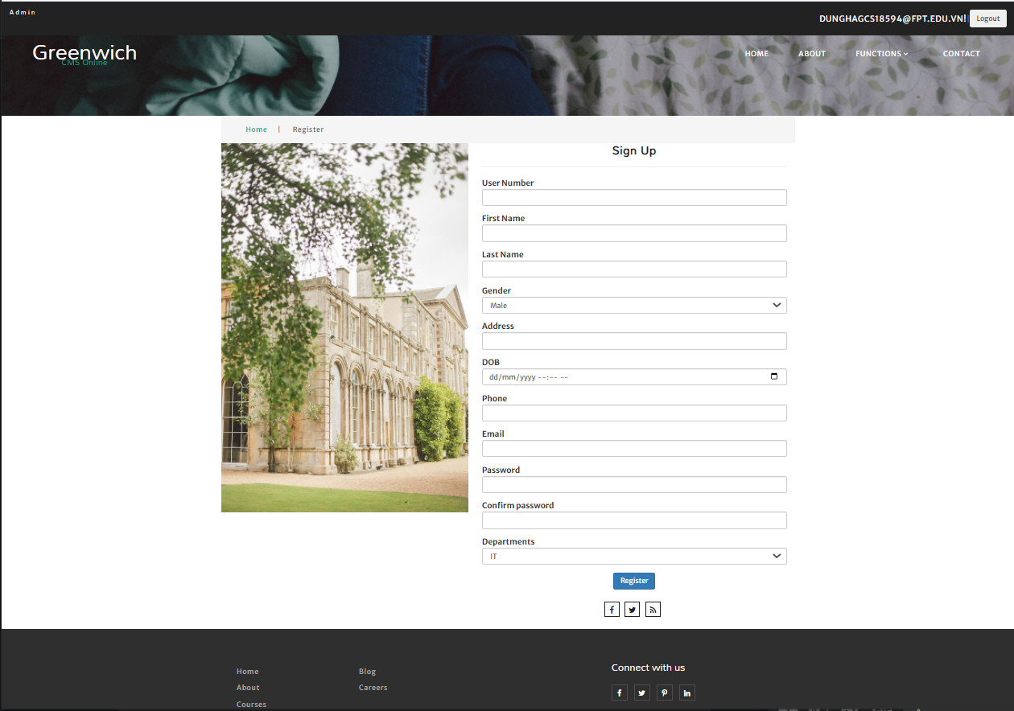

**Figure 41: Registration page**

**User page:**

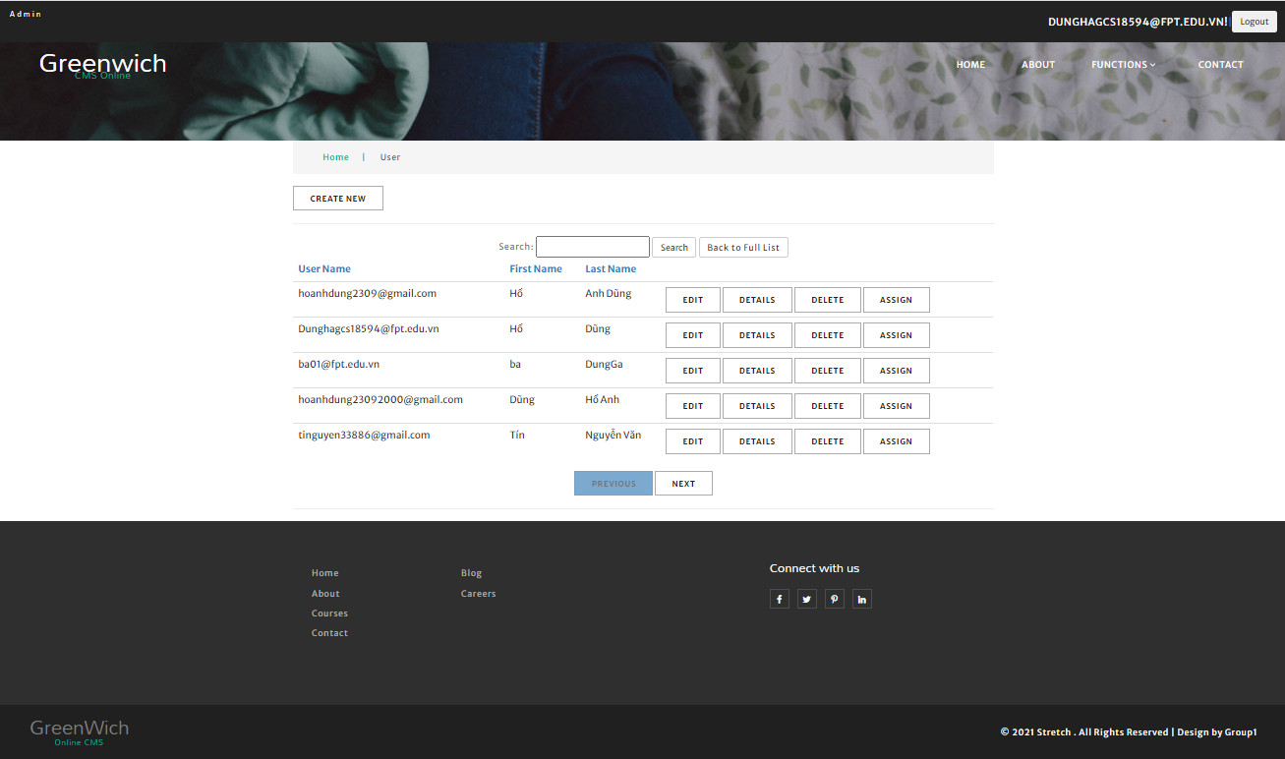

**Figure 42: User page**

**Assign Role page:**

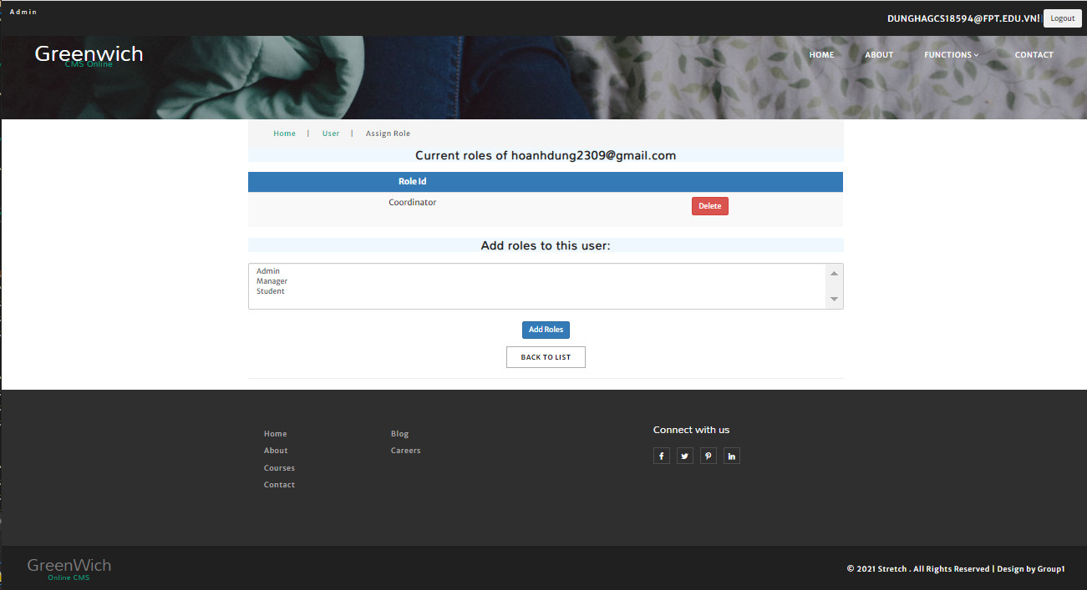

**Figure 43: Assign Role page**

**Role page:**

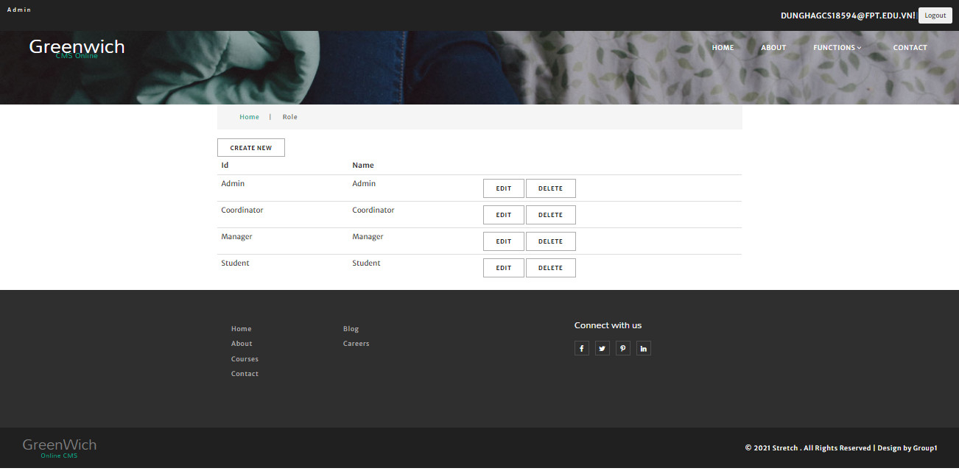

**Figure 44: Role page**

**Topics page:**

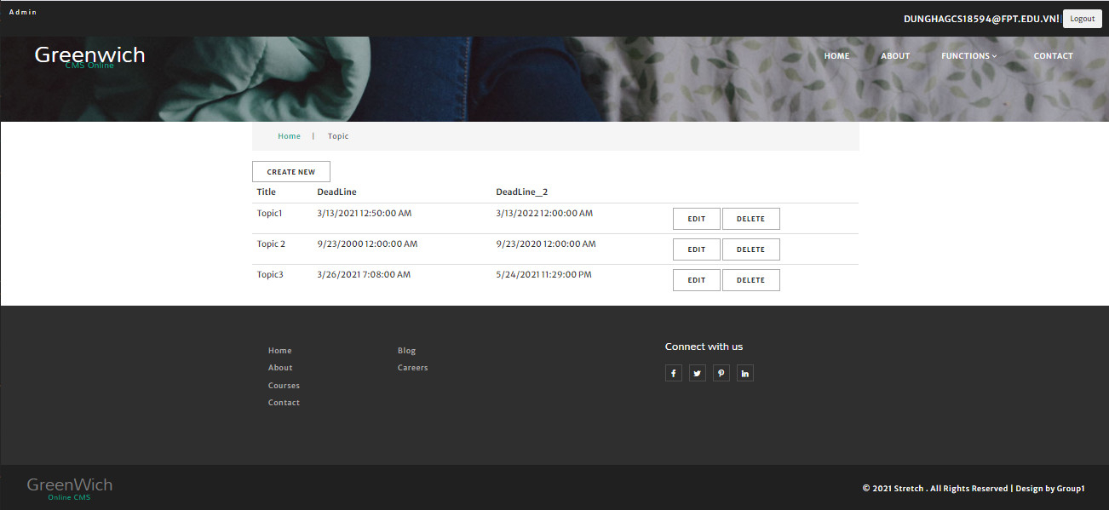

**Figure 45: Topics page**

**Department page:**

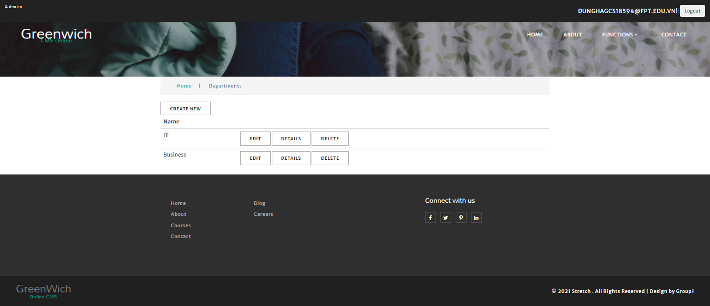

**Figure 46: Department page**

**Index Coordinator page:**

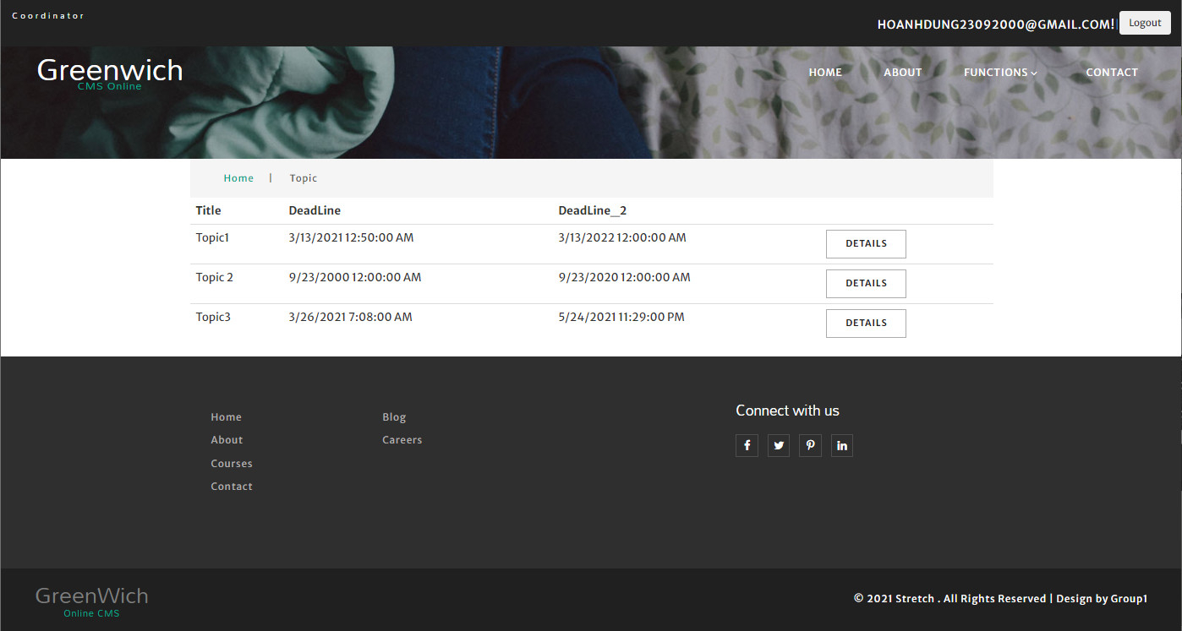

**Figure 47: Index Coordinator page**

**Download topic page:**

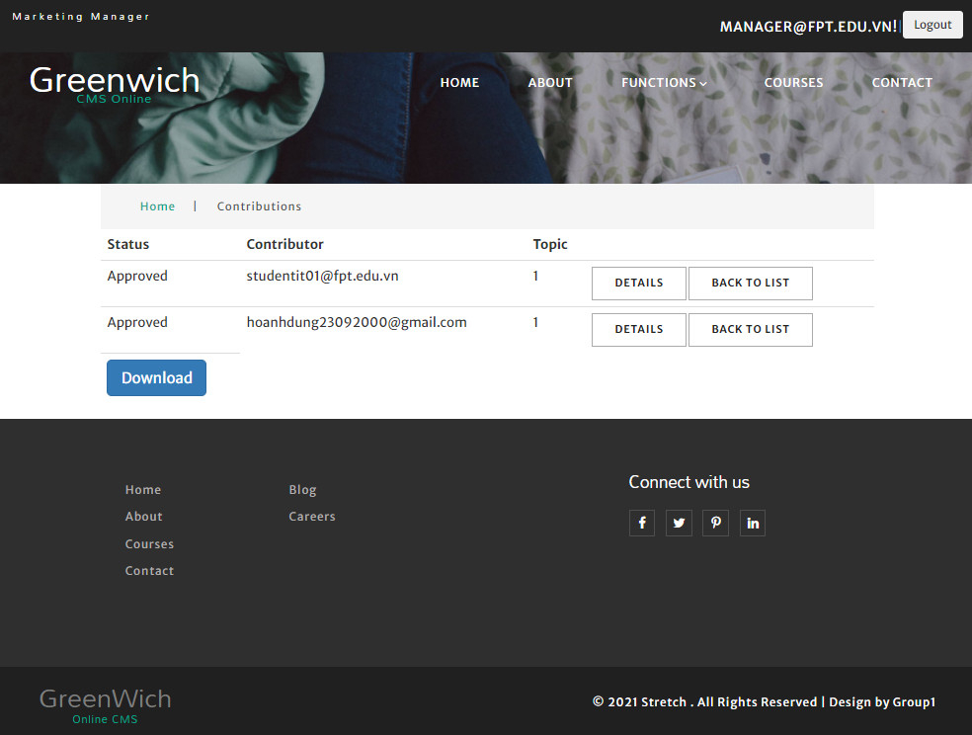

**Figure 48: Download topic page**

**Contribution coordinator page:**

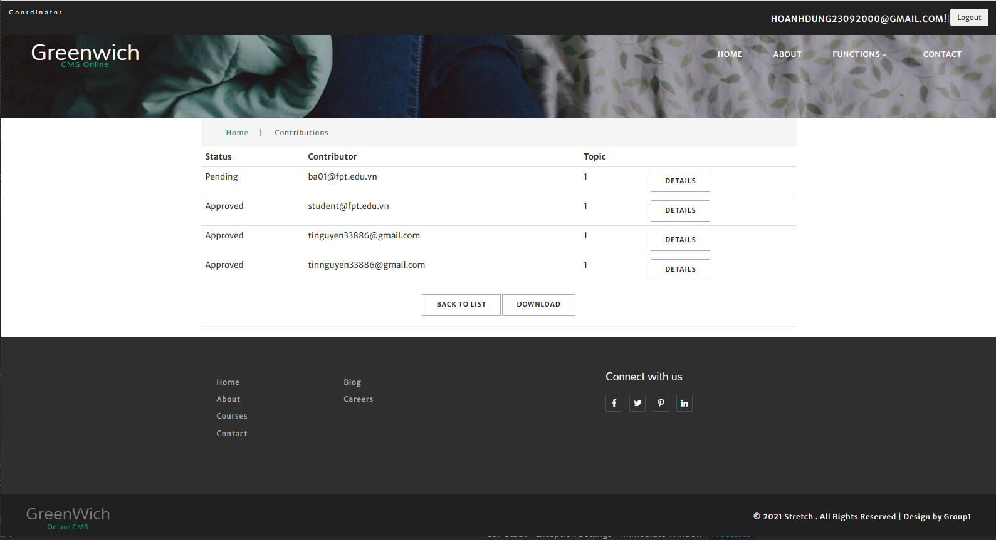

**Figure 49: Contribution coordinator page**

**Details contribution coordinator page:** 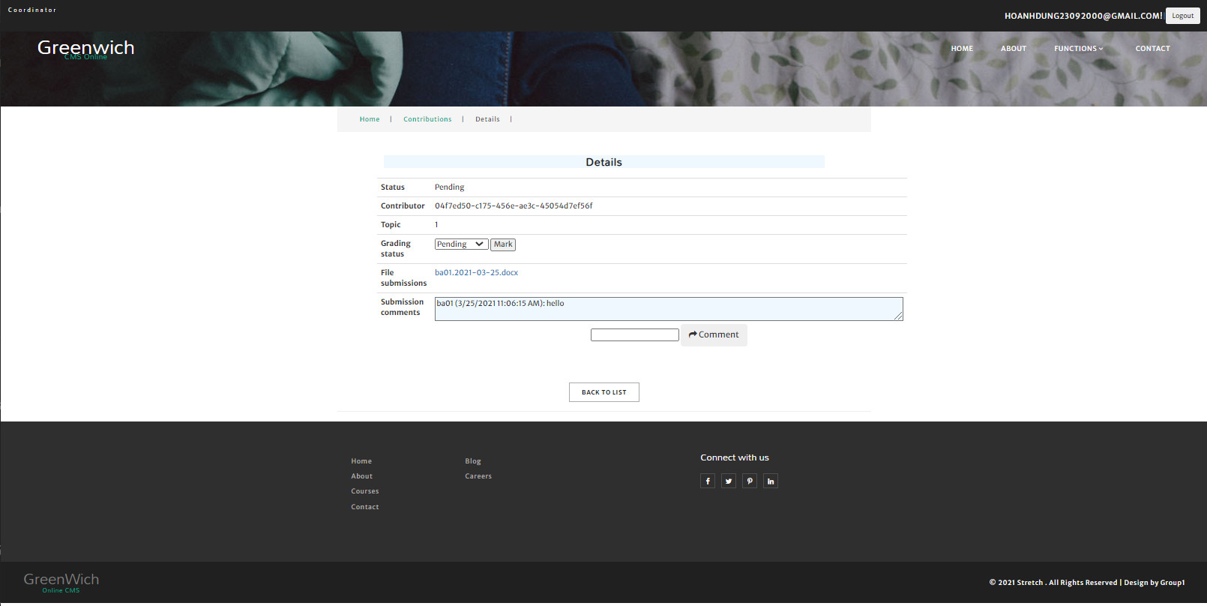

**Figure 50: Details contribution coordinator page**

**Index student page:**

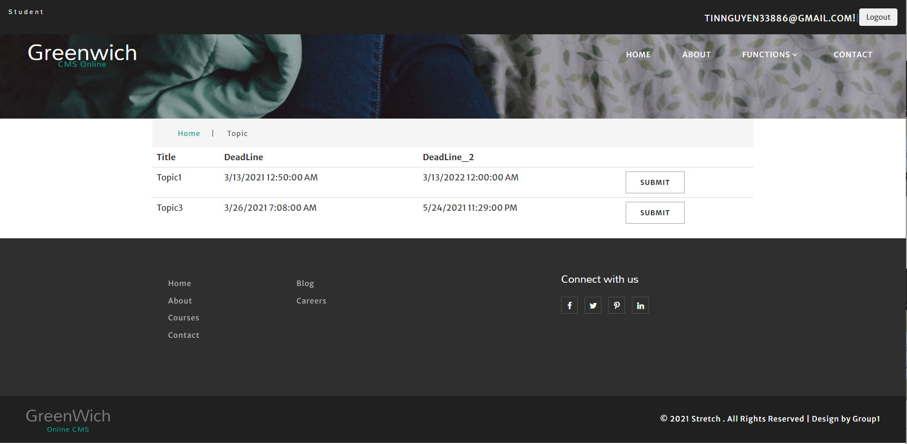

**Figure 51: Index student page**

**Index submit student page:**

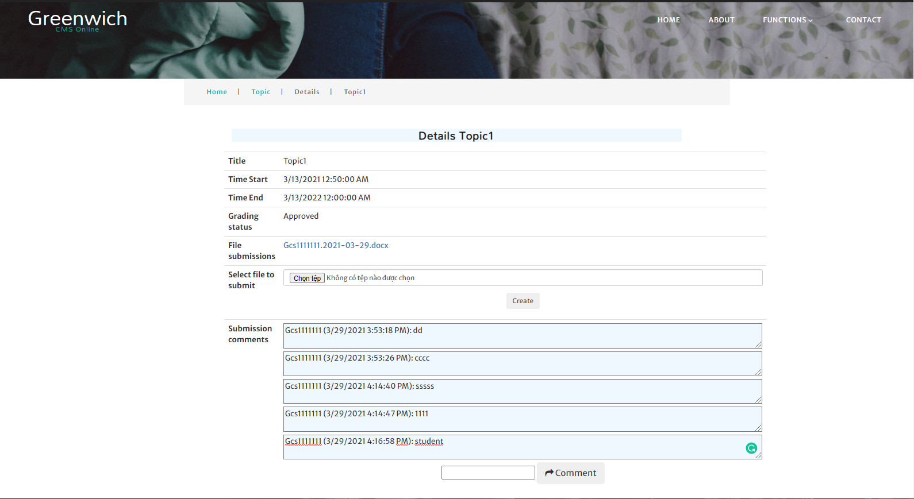

**Figure 52: Index submit student page**

**Index manager page:**

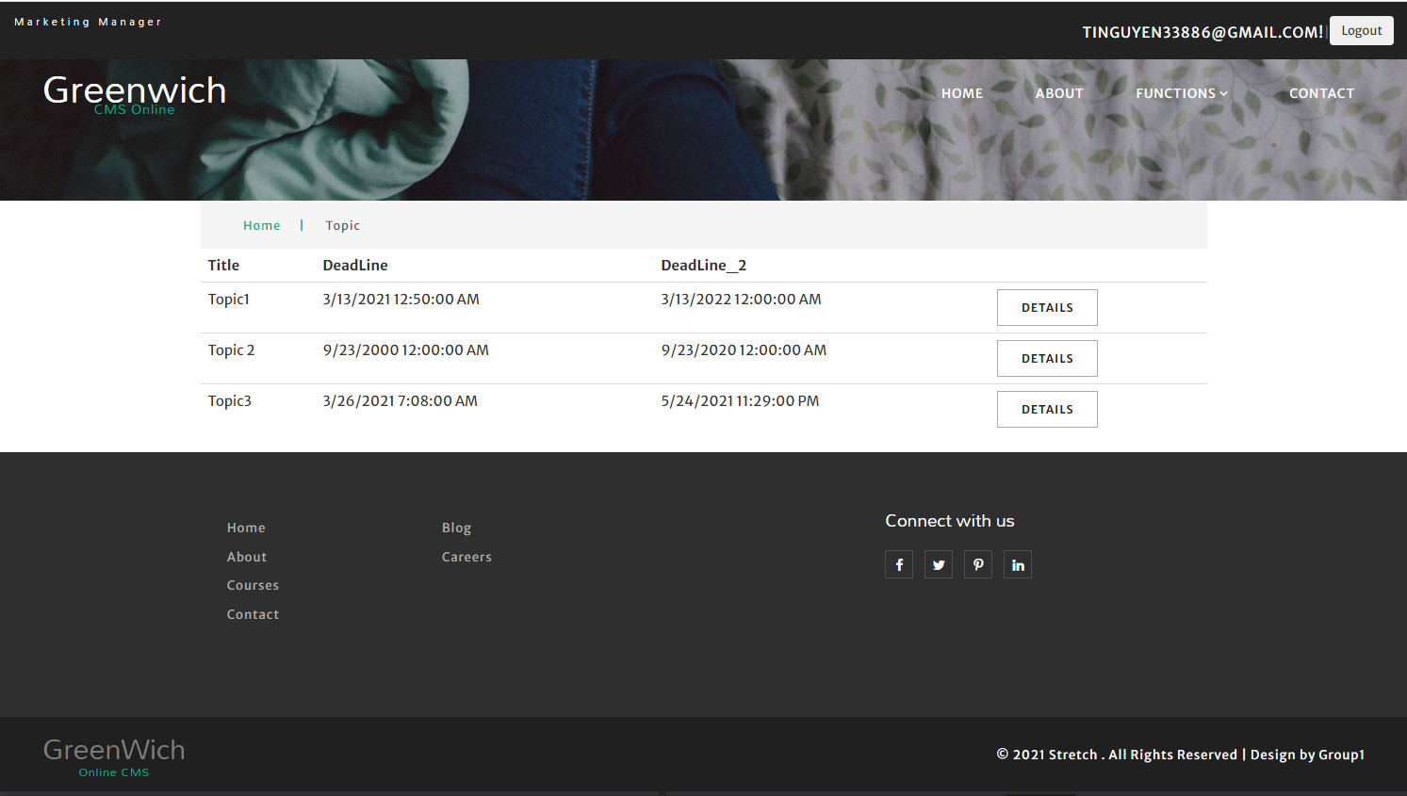

**Figure 53: Index manager page**

**Index Contribution manager page:**

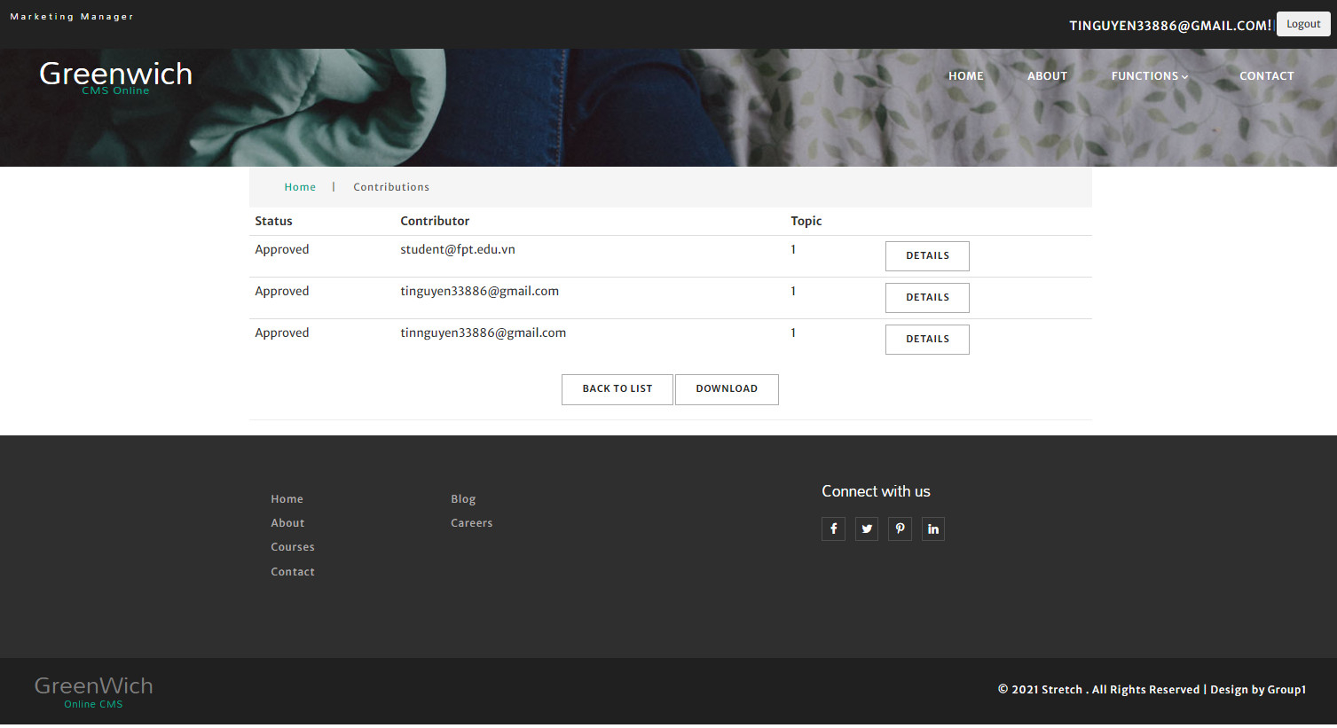

**Figure 54: Index Contribution manager page**

**Report page:**

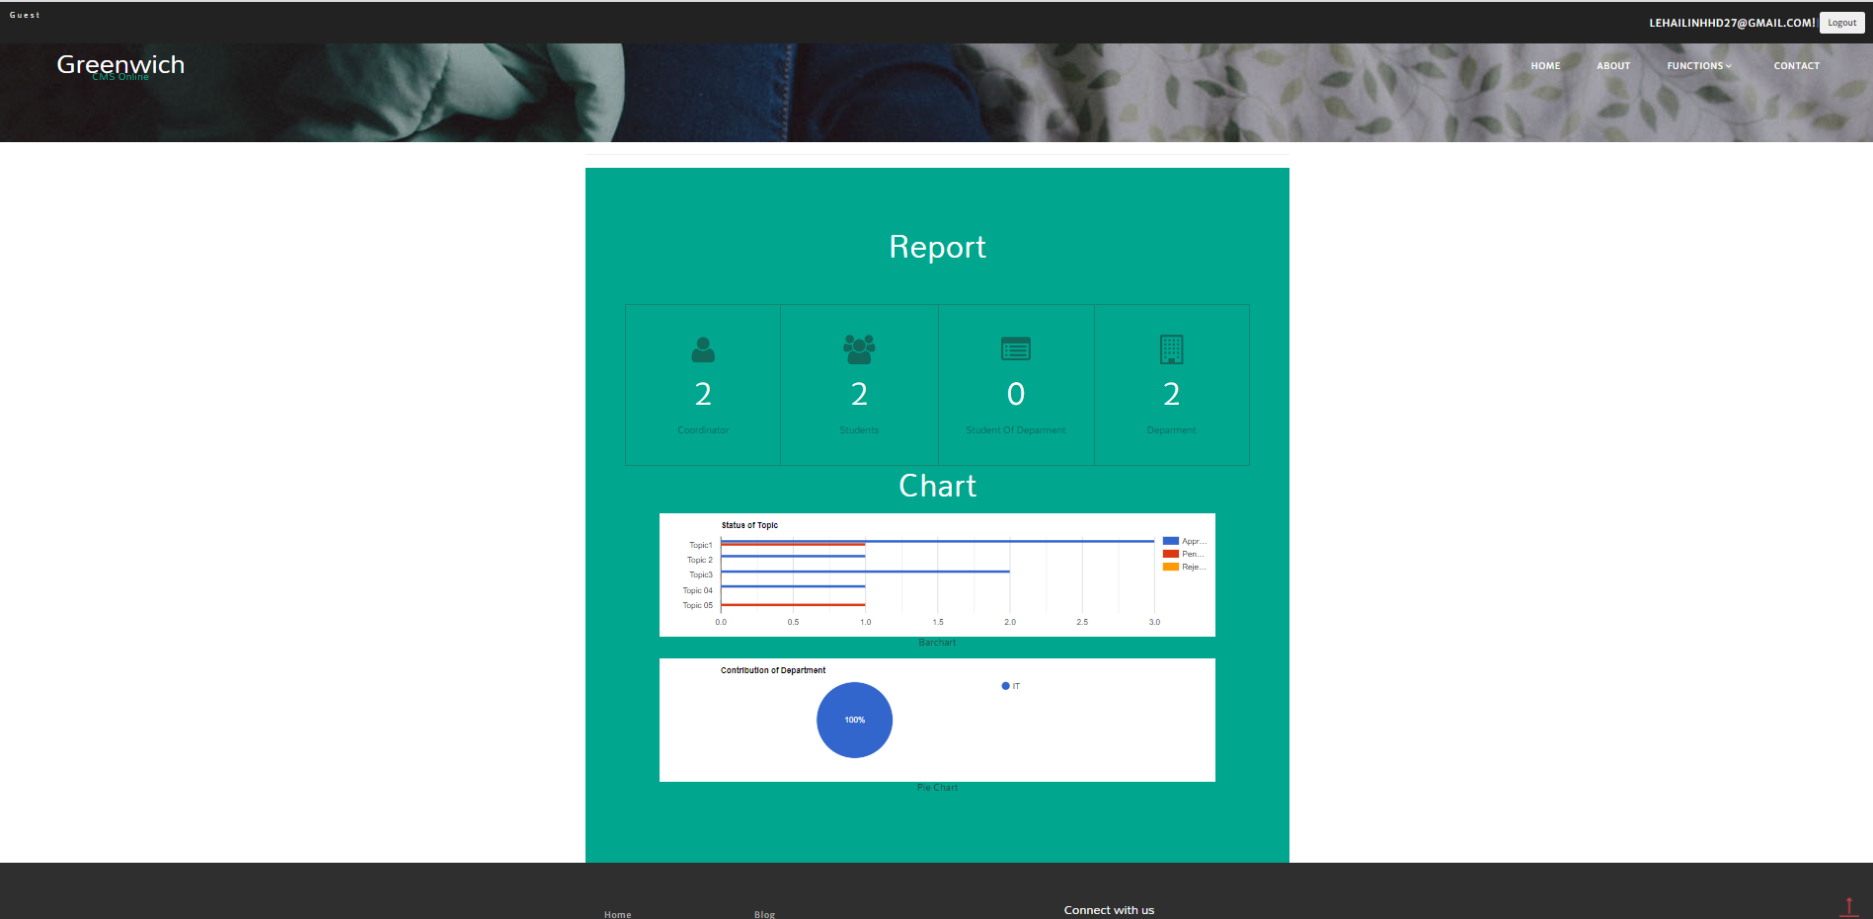

**Figure 55: Report page**

**Chat page:**

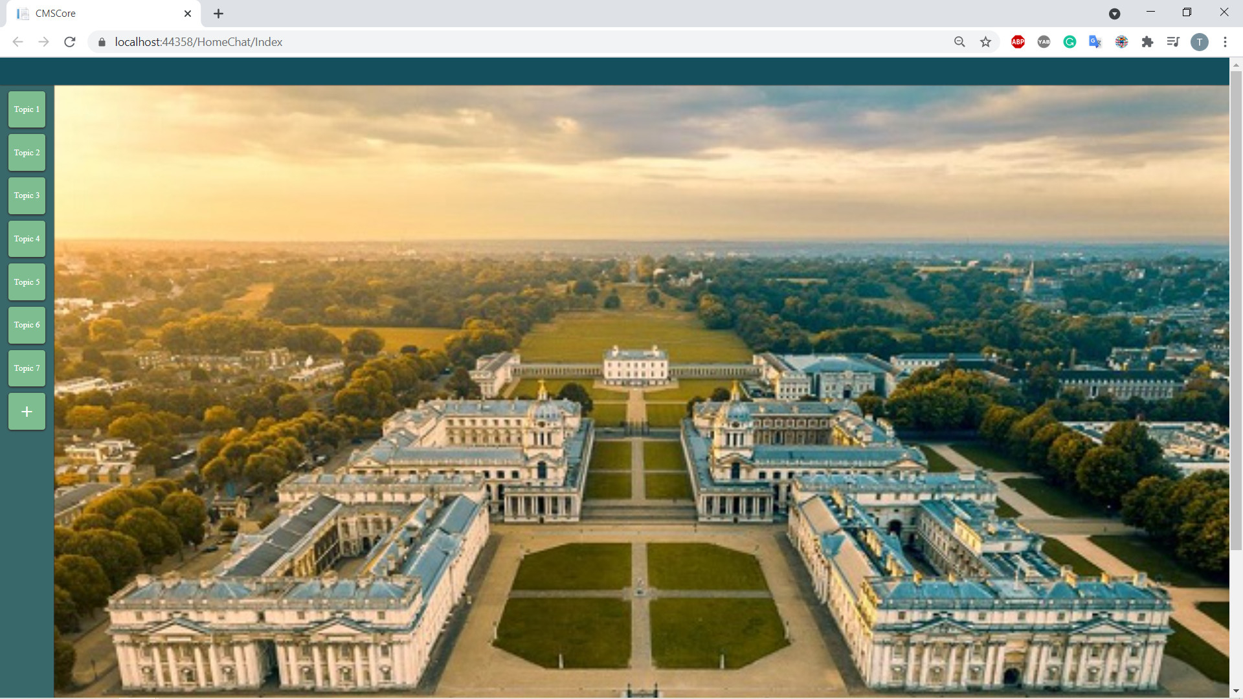

**Figure 56: Add new chat box**

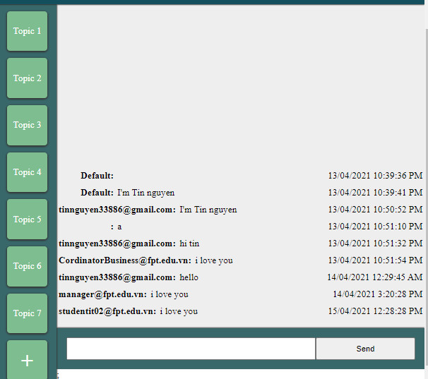

**Figure 57: Chat box**

# VIX. Links:

**Trello:**

[**https://trello.com/b/027EHozz/cmsapplication**](https://trello.com/b/027EHozz/cmsapplication)

**Burndown Chart:**

[**https://www.burndownfortrello.com/index.php?fbclid=IwAR2n93SN6NMcq0_gUi_DEYHNEAWdLcZNksGrEysMpQcA79JRCsmP5WtOSwo#**](https://www.burndownfortrello.com/index.php?fbclid=IwAR2n93SN6NMcq0_gUi_DEYHNEAWdLcZNksGrEysMpQcA79JRCsmP5WtOSwo)

**Team Meeting:**

[**https://teams.microsoft.com/_?culture=vi-vn&country=VN&lm=deeplink&lmsrc=homePageWeb&cmpid=WebSignIn#/xlsx/viewer/teams/https:~2F~2Ffeedu.sharepoint.com~2Fsites~2FFGWEnterpriseWeb2021.01-TCS2010PPT-Group01~2FShared%20Documents~2FGroup%2001~2FDaily%20Meeting.xlsx?threadId=19:ecff500f31fe4e9ea61ff6f3abbeed0f@thread.tacv2&baseUrl=https:~2F~2Ffeedu.sharepoint.com~2Fsites~2FFGWEnterpriseWeb2021.01-TCS2010PPT-Group01&fileId=8fbff95c-4a3e-4473-87b7-72b06c087232&ctx=files&rootContext=items_view&viewerAction=view**](https://teams.microsoft.com/_?culture=vi-vn&country=VN&lm=deeplink&lmsrc=homePageWeb&cmpid=WebSignIn#/xlsx/viewer/teams/https:~2F~2Ffeedu.sharepoint.com~2Fsites~2FFGWEnterpriseWeb2021.01-TCS2010PPT-Group01~2FShared%20Documents~2FGroup%2001~2FDaily%20Meeting.xlsx?threadId=19:ecff500f31fe4e9ea61ff6f3abbeed0f@thread.tacv2&baseUrl=https:~2F~2Ffeedu.sharepoin)

# X. References: